NORTH ATLANTIC TREATY  ORGANIZATION |  |  |  | SCIENCE AND TECHNOLOGY  ORGANIZATION
 |  |  |  | 
AC/323() |  |  |  |  | www.sto.nato.int
STO technical report |  | PUB REF NBR (STO-TR-MSG-134)
NATO Simulation Interoperability Test and Certification Service - Concept of Operations (CONOPS)

Version 1.0 D6


NATO Simulation Interoperability Test and Certification Service - Concept of Operations
Executive Summary
<TBC>

Abstract
<TBC>

Keywords
Federation of simulations, Interoperability, High Level Architecture, Integration, Verification, Certification, Capability badge

Table of Contents
List of Figures and Tables vi
List of Acronyms viii
Glossary xii
[MSG-134] Membership List xv
Chapter 1 - OVERVIEW 1
1.1 Identification 1
1.1.1 Revision History 1
1.2 Document Overview 2
1.3 System Overview 2
Chapter 2 - CURRENT SYSTEM SITUATION 4
2.1 Background, Objectives, and Scope 4
2.2 Operational Constraints 4
2.3 Description of the Current System 4
2.4 User Profiles 5
2.5 Support Environment 5
Chapter 3 - JUSTIFICATION AND NATURE OF THE CHANGES 6
3.1 Justification for Changes 6
3.2 Description of the Desired Changes 8
3.3 Priorities 8
3.4 Changes Considered but Not Included 9
3.5 Assumptions and Constraints 9
Chapter 4 - CONCEPT OF THE PROPOSED SYSTEM 10
4.1 BACKGROUND, OBJECTIVES AND SCOPE 10
4.2 KEY ROLES 11
4.2.1 Accreditation Authority 11
4.2.2 Certification Entity 11
4.2.3 Accredited Test Laboratory 11
4.3 KEY COMPONENTS 12
4.3.1 Interoperability Requirements 13
4.3.2 Abstract Test Case 13
4.3.3 Interoperability Capability Badges 14
4.3.4 Conformance Statement 16
4.3.5 Integration Verification and Certification Tool (IVCT) 17
4.3.6 Information available to the public via the CE website 18
Chapter 5 - OPERATIONAL SCENARIOS 19
5.1 ACCREDITATION AND CERTIFICATION 19
5.2 ACCREDITATION PROCESS OF A CANDIDATE FOR THE ATL ROLE 20
5.3 ACCREDITATION PROCESS OF A CANDIDATE FOR THE CE ROLE 20
5.4 DEVELOPMENT AND MAINTENANCE 21
Chapter 6 - SUMMARY OF IMPACTS 25
Chapter 7 - ANALYSIS OF THE PROPOSED SYSTEM 26
Chapter 8 - BUSINESS MODEL 27
8.1 BUSINESS OF CERTIFICATION ACTIVITY 27
8.2 CUSTOMER FUNDED BUSINESS MODEL 27
8.2.1 Early development (2015-2017) 27
8.2.2 Initial Operational Capability (2018-2020) 28
8.2.3 Fully Operational Capability (2021 and beyond) 28
8.3 PROPOSED ORGANIZATION 29
8.4 STRATEGY FOR INITIAL OPERATIONAL CAPABILITY 30
8.5 BUSINESS MODEL FOR THE TRANSITION PERIOD FROM IOC TO FOC 31
8.6 OWNERSHIP OF THE IVCT, ABSTRACT TEST CASES, AND EXECUTABLE TEST CASES 31
Chapter 9 - REFERENCED DOCUMENTATION 32
Annex A - OPERATING PROCEDURES 33
A.1 ROLES AND RESPONSIBILITIES 33
A.1.1 Accreditation Authority 33
A.1.2 Certification Entity 34
A.1.3 Accredited Test Laboratory 37
A.1.4 Customer 39
A.2 POLICIES AND CONSTRAINTS 40
A.3 USE CASES AND SCENARIOS 42
A.3.1 Accreditation and Certification 42
A.3.2 Accreditation process of a candidate for the ATL role 43
A.3.3 Accreditation process of a candidate for the CE role 43
A.3.4 Perform Certification Test 43
A.3.5 Definition of Certification work flow 45
A.3.6 Development and Maintenance 46
Annex B - CAPABILITY BADGES, INTEROPERABILITY REQUIREMENTS AND ABSTRACT TEST CASES 51
B.1 INTEROPERABILITY CAPABILITY BADGES 51
B.2 INTEROPERABILITY REQUIREMENTS 55
B.3 ABSTRACT TEST CASES 67
Annex C - CONFORMANCE STATEMENT 69
Annex D - INTEGRATION, VERIFICATION AND CERTIFICATION TOOL 70

List of Figures and Tables
Figure 1-1: NOV-1 NATO Simulation Interoperability Test and Certification Service 3
Figure 3-1: Increase Interoperability, Reuse, and Cost Effectiveness 8
Figure 4-1 - New scope of interoperability certification 10
Figure 4-2: NOV-4 Organizational relationships and key roles 11
Figure 4-3: Key concept used in certification service 12
Figure 4-4: Relationships between the concepts of a CB, its associated IRs, and the System-under-Test 15
Figure 4-5: Major IVCT modules 17
Figure 4-6: Using IVCT 18
Figure 5-1: Use Case of Certification Service 19
Figure 5-2: Use Case of Development 21
Figure 5-3: Definition of certification workflow Use Case Diagram 23
Figure 8-1: Funding of IVCT and Certification Service 29
Figure 8-2: Proposed Organizational structure 30
Figure A-1: NOV-2 User Roles 33
Figure A-2: Use case of Certification Service 42
Figure A-3: Use case of Perform Certification Test 44
Figure A-4: Use case of Definition Certification Workflow 45
Figure A-5: Use case of Development 46
Figure A-6: Use case of Test Tool Development 48
Figure A-7: Use case of Test Case Implementation 49
Figure B-1: Key elements of the certification process 51
Figure B-2: Relationships between a CB its associated IRs and the System-under-Test (SuT) 52
Figure D-1: Major IVCT modules 70
Figure D-2: Using IVCT 71

Table 4-1: Categories of Interoperability Requirements 13
Table 4-2: First set of Abstract Test Cases 14
Table 4-3: Initial set of Capability Badges 16
Table 5-1: Use cases related to Certification Service 20
Table 5-2: Use cases related to Development 22
Table 5-3: Use cases of Verification Workflow 24
Table 7-1: Analysis results of certification service 26
Table A-1: Initial operational requirements of Accreditation Authority 33
Table A-2: Use cases related to Accreditation Authority 33
Table A-3: Operational requirements of Certification Entity 34
Table A-4: Use cases related to Certification Entity 36
Table A-5: Operational requirements of Accredited Test Laboratory 37
Table A-6: Use cases related to Accredited Test Laboratory 38
Table A-7: Operational requirements of Customer 38
Table A-8: Use cases related to Customer 39
Table A-9: Operational requirements for Operational Policies and constraints 41
Table A-10: Use cases related to Certification Service 42
Table A-11: Use cases related to Perform Certification Test 43
Table A-12: Use cases related to Definition Certification Workflow 45
Table A-13: Use cases related to Development 46
Table A-14: Use cases related to Test Tool Development 47
Table A-15: Use cases related to Test Case Implementation 49
Table B-1: Interoperability Capability Badges 54
Table B-2: Categories of Interoperability Requirement 55
Table B-3: Initial set of Interoperability Requirements 66
Table B-4: Set of Abstract Test Cases 67

List of Acronyms
AA | Accreditation Authority
AAR | After Action Review
AIMS | Architectures, Interoperability and Management of Simulation
AMSP | Allied Modelling and Simulation Publication
ATC | Abstract Test Case
ATL | Accredited Test Laboratory
ATS | Abstract Test Suit
AuxF | Auxiliary Federate
AuxS | Auxiliary Service
BGR | Bulgaria (NATO Country Code)
CA | Certification Agent
CAN | Canada (NATO Country Code)
CAX | Computer Assisted eXercise
CB | Capability Badge
CE | Certification Entity
CeAG | Certification Advisory Group
CFI | Connected Forces Initiative
CIGI | Common Image Generator Interface
CIS | Communication and Information System
COE | Centre of Excellence
CONOPS | Concept of Operations
COTS | Commercial Off-the-Shelf
CS | Conformance Statement
CSO | STO Collaboration Support Office
CWIX | Coalition Warrior Interoperability eXploration, eXperimentation, eXamination, eXercise
CZE | Czech Republic (NATO Country Code)
DEU | Germany (NATO Country Code)
DIS | Distributed Interactive Simulation
DSA | Distributed Simulation Agreement
DSEEP | Distributed Simulation Engineering and Execution Process
DSTL | Defence Science and Technology Laboratory
DVCS | Distributed Version Control System
ET | Exploratory Team
ETC | Executable Test Case
EXCON | EXercise CONtrol
ESC | Exercise Specification Conference
FA | Focus Area
FAFD | Federation Architecture and FOM Design
FCC | Final Coordination Conference
FCTS | Federate Compliance Test System
FCTT | Federate Compliance Test Tool
FMN | Federated Mission Networking
FOC | Final Operational Capability
FOM | Federation Object Model
FRA | France (NATO Country Code)
FTMS | Federate Test Management System
GBR | United Kingdom (NATO Country Code)
GMF | German Maritime FOM
GNU | GNU not unix
GOTS | Government Off-the-Shelf
GPL | GNU General Public License
GUI | Graphical User Interface
HLA | High Level Architecture
IED | Improvised Explosive Device
IEEE | Institute of Electrical and Electronics Engineers
I/ITSEC | Interservice / Industry Training, Simulation and Education Conference
IOC | Initial Operating Capability
IPC | Initial Planning Conference
IR | Interoperability Requirement
ISBN | International Standard Book Number
ITA | Italy (NATO Country Code)
ITEC | International Training and Education Conference
IVCT | Integration, Verification, and Certification Tool
JFTC | Joint Force Training Center
JMS | Java Message Service
JSON | JavaScript Object Notation
JWC | Joint Warfare Center
LAMP | Linux, Apache, MySQL, PHP
LCIM | Levels of Conceptual Interoperability Model
LGPL | GNU Lesser General Public License
MC | Military Committee
MEL | Master Event List
METOC | Meteorological and Oceanographic
MIL | Master Incident List
MOT | Means of Testing
MPC | Main Planning Conference
MPL | Mozilla Public License
MSCO | Modelling and Simulation Coordination Office
MSDL | Military Scenario Definition Language
MSG | Modelling and Simulation Group
MS3 | Modelling and Simulation Standards Subgroup
M&S | Modelling and Simulation
NAC | North Atlantic Council
NATO | North Atlantic Treaty Organization
NC3B | NATO Consultation, Command and Control Board
NETN | NATO Education and Training Network
NMSG | NATO Modelling and Simulation Group
NRF | NATO Response Force
NSO | NATO Standardization Office
NSRL | NATO Simulation Resources Library
OMT | Object Model Template
OSS | Open Source Software
POL | Poland (NATO Country Code)
RPR | Real-Time Platform Reference
RTG | Research Task Group
RTI | Runtime Infrastructure
SISO | Simulation Interoperability Standards Organization
SIW | Simulation Innovation Workshop
SME | Subject Matter Expert
SOM | Simulation Object Model
STANAG | Standard NATO Agreement
STANREC | Standard NATO Recommendation
STO | NATO Science and Technology Organization
SuT | System under Test
SuTE | System under Test Environment
SuTO | System under Test Operator
SWE | Sweden (NATO Country Code)
SWOT | Strengths, Weaknesses, Opportunities, and Threats
SQL | Structured Query Language
TAP | Technical Activity Proposal
TC | Technical Column
TE | Test Engine
TL | Test Laboratory
URL | Uniform Resource Locator
USA | United States (NATO Country Code)
WAN | Wide Area Network

Glossary
Abstract Test Case | ISO/IEC 9646-1: A complete and independent specification of the actions required to achieve a specific test purpose (or a specified combination of test purposes), defined at the level of abstraction of a particular Abstract Test Method, starting in a stable state for testing and ending in a stable state for testing. This specification may involve one or more consecutive or concurrent connections.
Abstract Test Method | ISO/IEC 9646-1: The description of how an IUT is to be tested, given an appropriate level of abstraction to make the description independent of any particular realization of a Means of Testing, but with enough detail to enable tests to be implemented for this test method.
Abstract Test Suite | ISO/IEC 9646-1: A test suite composed of abstract test cases.
Accreditation Authority (AA) | DoD M&S Glossary: The organization or individual responsible to approve the use of models, simulations, and their associated data for a particular application.
Accreditation | DoD M&S Glossary: The official certification that a model, simulation, or federation of models and simulations and its associated data are acceptable for use for a specific purpose.
Accredited Test Laboratory | A Test Laboratory which has been accredited by an Accreditation Authority to perform Compliance Testing.
Capability Badge | A token of achievement in terms of passing a test related to Interoperability Requirements
Certification Agent | An entity or person that has been approved by the Accreditation Authority to perform Compliance Testing.
Certification artefact | IEEE-24765-2010: The tangible results from a certification process.
Certification criteria | IEEE-24765-2010: A set of standards, rules, or properties to which an asset must conform in order to be certified to a certain level.
Certification Process | IEEE-24765-2010: The process of assessing whether an asset conforms to predetermined certification criteria appropriate for that class of asset.
Certification Property | IEEE-24765-2010: A statement about some feature or characteristic of an asset that may be assessed as being true or false during a certification process.
Certification Test | The software testing portion of the Certification Process.
Certification | IEEE-24765-2010: The process of confirming that a system or component complies with its specified requirements and is acceptable for operational use.
Compliance Certificate | Adapted from IEEE-24765-2010: A written guarantee that a system or component complies with its specified requirements and is acceptable for operational use.
Compliance Testing | The process of testing the behaviour of an asset against a given standard conducted by the test tool.
Compliance | The statement that an asset fulfils the required behaviour rules of a given standard.
Concept of Operations | IEEE 1362-1998: A user-oriented document that describes the characteristics of a proposed system from the users' viewpoint. The document is used to communicate the overall quantitative and qualitative system characteristics to the user, buyer, developer and other organizational elements (e.g. training, facilities, staffing, and maintenance). It is used to describe the user organization(s), mission(s) and organizational objectives from an integrated systems point of view.
Conformance Statement | A written statement that confirms the conformance of a System under Test (SuT) to a given standard.
Conformance | Conformance is a synonym for Compliance.
Customer | An entity (or a person) who has sufficient legal rights to submit a given federate to compliance testing and to allow the CA to publically announce the compliance of the SuT (System under Test).
Federate Owner | An entity (or a person) who has legal ownership rights to a given federate.
Federate | IEEE-1516-2010: An application that may be or is currently coupled with other software applications under a federation object model (FOM) Document Data (FDD) and a runtime infrastructure (RTI).
Federation | IEEE-1516-2010: A named set of federate applications, and a common federation object model (FOM) that are used as a whole to achieve some specific objective.
Integration, Verification, and Certification Tool (IVCT) | A software framework to support integration and verification tasks for simulation federate development and to perform certification tests for a SuT (System under Test).
Means of Testing | ISO/IEC 9646-1: The combination of equipment and procedures that can perform the derivation, selection, parameterization and execution of test cases, in conformance with a reference standardized ATS, and can produce a conformance log.
Science Connect | Collaborative Workspace provided by NATO CSO.
System under Test (SuT): | The System which is the target of Compliance Testing. An SuT is an instance of an asset.
System under Test Environment (SuTE) | Environment required for the SuT to function correctly for certification tests.
Test Case Developer | Individuals / organizations responsible for the design, implementation and maintenance of the test cases.
Test Case | IEEE-829-2008: A set of test inputs, execution conditions, and expected results developed for a particular objective, such as to exercise a particular program path or to verify compliance with a specific requirement.
Test Class | IEEE-829-2008: A designated grouping of test cases.
Test Federate | Is a member application that is part of the IVCT and that tests whether the SuT (System under Test) complies with (a subset of) the federation agreements.
Test Laboratory | An entity which has the technical capabilities to perform the tests specified for a SuT (System under Test).
Test Procedure | IEEE-829-2008: Detailed instructions for the setup, execution, and evaluation of results for a given test case.
Test Tool Developer | Individuals / organizations responsible for the design, implementation, and maintenance of the certification tool (IVCT).
Test | IEEE-829-2008: The activity of executing a Test Procedure/Test Case.
WebEx | Web-based teleconferencing system provided by NATO CSO.

[MSG-134] Membership List
<TBC>

OVERVIEW

Identification
The system described in this Concept of Operations (CONOPS) covers the organisation, process and tools to support NATO certification of simulation components' interoperability capability and is referred to as the NATO Simulation Interoperability Test and Certification Service. This includes, but is not limited to, simulation interoperability agreements as specified in the NETN Federation Agreement and FOM Document [AMSP-04], Capability Badges, and Interoperability Requirements.

Title | NATO Simulation Interoperability Test and Certification Service - Concept of Operations (CONOPS)
Activity Reference | MSG-134: NATO Distributed Simulation Architecture & Design, Compliance Testing and Certification
Originator's Reference | STO-xx-MSG-134 ...
ISBN Reference | ISBN xxxx
Security Classification | PUBLIC RELEASE
Originator | NATO Science and Technology Organization
Published | xxx 2017
Distribution Statement | This document is distributed in accordance with NATO Security Regulations and STO policies.

Revision History
Date | Version | Description | Sign
2015-09-21 | v1.0 D1 | Initial Draft | BL
2015-12-07 | v1.0 D2 | Updates based on comments from 8th Meeting (MSG-134). Major clean-up between Req. spec and CONOPS. | BL
2016-02-18 | v1.0 D3 | Updates based on the IITSEC meeting and received comments till 2-18-2016 | JH
2016-07-14 | v1.0 D4 | Major update based on comments and actions. Harmonization of definitions, inclusion of annexes with detailed information. | BL
2017-10-05 | V1.0 D5 | Updates based on comments from 25th Meeting (MSG-134) | JR
2017-10-18 | V1.0 D6 | Update of customer funded business model | JR

Document Overview
The primary audience of this document is the members of the MSG-134 Research Task Group (RTG) and other research groups in the NATO Modelling and Simulation Group (NMSG).
The main purpose of this document is to communicate and build consensus on:
- the needs of users and the proposed system expectations
- the proposed business model, processes, and roles
- the scope of work for MSG-134 activities in the realization of the system
- the system developer's understanding of user needs and how the system will meet those needs
Furthermore, the CONOPS is a deliverable of MSG-134 and a summary of the CONOPS will be included in the MSG-134 final technical report, in papers and presentations, and in other marketing and information material.
Chapter 1 provides an overview of the NATO Simulation Interoperability Test and Certification Service.
Chapter 2 provides references to background material and related documentation.
Chapter 3 describes the current state of the system and issues.
Chapter 4 describes the rationale and justification for the proposed service.
Chapter 5 describes the main concepts and constructs of the proposed service.
Chapter 6 describes in more detail the different operational scenarios.
Chapter 7 provides a summary of the impacts of the proposed service.
Chapter 8 provides a Strengths, Weaknesses, Opportunities, and Threats (SWOT) analysis of the proposed service.
Chapter 9 describes the service business model.

System Overview
MSG-134 delivers a system for certification, including processes and tools, to enable cost-effective and reliable Plug & Play of multinational simulations for the warfighter.
The purpose of the system is to implement a capability for NATO certification of simulation components' interoperability. The system consists of organizations, roles, processes and tools. The system is used to verify individual simulation component compliance with NATO interoperability standards for modelling and simulation, and to provide certificates of compliance for simulation components that successfully complete the certification process.
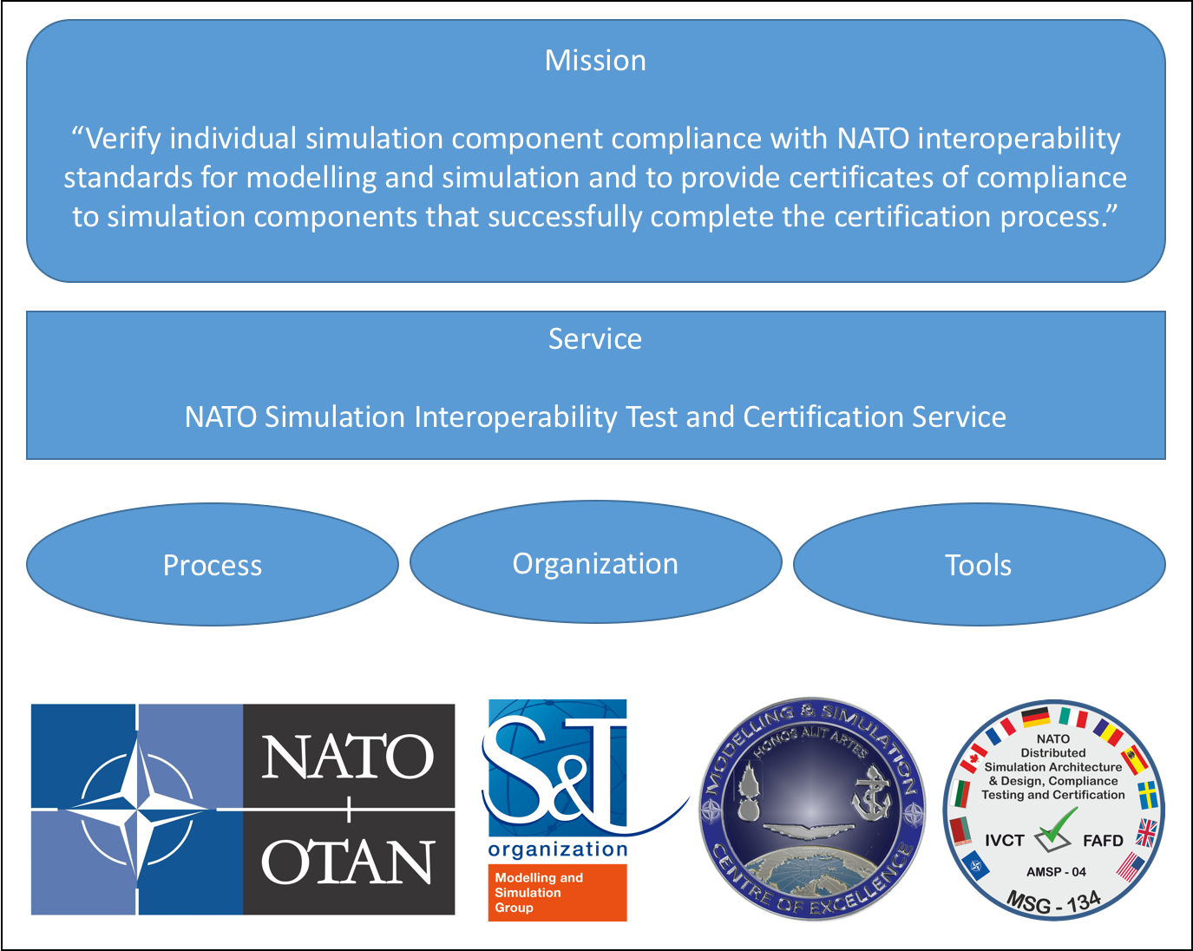
Figure 1-1: NOV-1 NATO Simulation Interoperability Test and Certification Service
The Integration, Verification, and Certification Tool (IVCT) is defined as a software package supporting test and verification in the certification process. However, the IVCT is also expected to be available for other test and integration activities in other processes.

CURRENT SYSTEM SITUATION

Background, Objectives, and Scope
The integration of distributed simulations and tools into interoperable federations is a complex and time-consuming task requiring extensive testing of individual components, interfaces, and the integrated solution. To support this task, NATO identifies standards and common agreements and relies on partners to comply with these standards. The NATO M&S Standards Profile [AMSP-01], provides a list of recommended M&S related standards. The NATO Education and Training Network Federation Architecture and Federation Object Model (FOM) Design Document (NETN FAFD) [AMSP-04] developed by MSG-068 and MSG-106 provides additional agreements on the use of standards to support distributed simulation. High Level Architecture (HLA) [STANAG4603] is identified as one of the core standards for distributed simulation. It states that Participating nations agree to use the HLA Compliance Certification Process established by the NATO Modelling and Simulation Group (NMSG).
The Federate Compliance Test System (FCTS) software tool manages and performs the compliance verification processes for interoperable High Level Architecture (HLA) based federates built in compliance with the HLA 1.3 and IEEE 1516-2000 standards for modelling and simulation. It consists of the Federate Compliance Test Tool (FCTT) and the Federate Test Management System (FTMS). These tools were developed by the USA and released to NATO in 2004. The NATO Certification Advisory Group (CeAG) was established as a subgroup to NMSG to create a community of NATO nations willing to provide certification services using FCTS. NATO certification services were established and are, or have, been operational in France, the USA, and Sweden. This document supersedes the HLA Certification Testing Capability procedures produced by the HLA Working Group – MSG-050.

Operational Constraints
The FCTT developed by the USA has undergone several updates based on feedback from the user community. However, due to export restrictions, new versions of FCTT have not been released to NATO. The NATO version of FCTT is currently limited to testing of compliance with HLA 1.3 and HLA IEEE 1516-2000 interfaces and cannot be used to test the latest version of HLA [IEEE 1516-2010].

Description of the Current System
The FTMS is a web-based management system that supports the certification process. Requests for certification and all artefacts required for submitting and performing certification testing are provided through the FTMS. The FCTT is the actual software that performs federate testing. It checks the System under Test (SuT) for compliance with a Conformance Statement (CS) provided by the owner of the SuT. The tests include the federates’ use of HLA services, and Object Model Template (OMT) / Simulation Object Model (SOM) consistency & conformance.

User Profiles
Testing is performed by a nationally designated Certification Agent and certificates are issued by a national Certification Entity.

Support Environment
The existing FCTS software is no longer maintained by the USA although a version has been made available as Open Source under GNU General Public License version 3.0 (GPLv3). No active contributions to the Source Forge project where the source code is hosted have been noticed.

JUSTIFICATION AND NATURE OF THE CHANGES

Justification for Changes
Standards, federation agreements, compliance testing and certification are important tools that will reduce integration risks, increase reuse of existing systems and support procurement of new interoperable simulation components. Updated and new standards for simulation interoperability require the NATO simulation certification service to be continuously maintained and updated to manage more complex test cases using the latest versions of applicable standards. Certification of simulation components requires additional testing beyond the HLA services interface to also include testing of compliance with federation agreements.
Due to the lack of support for the latest version of the HLA standard (IEEE 1516-2010) and the general need for additional types of testing, NATO has conducted research (ET-35 and MSG-134) on ways to move forward and provide an enhanced capability for simulation interoperability certification.
MSG ET-035 investigated the feasibility of developing an open source version of the FCTT that would be available to all NATO and Partner nations but concluded that the FCTT cannot be used as a foundation for a future certification tool. MSG ET-035 also concluded that HLA compliance tests needs to be extended beyond the HLA interface and data exchange testing to address more complex federation agreements and requirements.
MSG-134 researched and delivered (1) maintenance and update of the NETN FAFD and (2) procedures and reference implementations of Integration Verification and Certification Tools (IVCT) modules. This work is to support compliance testing and certification of NETN FAFD compliant simulation components including certification of STANAG 4603.
Within the M&S community, it is generally recognized that the technical interoperability between systems is no longer a fundamental problem. However, high-level interoperability is still considered a major challenge in establishing reliable and trusted federations of distributed simulations. The required degree of interoperability not only depends on the purpose and objectives of the simulation system but also on the federation design, and interoperability capabilities of selected system components. Early identification of interoperability issues reduces the risk and cost associated with less interoperable system components. A high degree of interoperability allows more flexible federation design and composability of simulation systems without significantly increasing the complexity and costs associated with test and integration. [Tolk03]
Depending on the degree of interoperability between participating simulation components, the integration of federates into complex federations can be a time-consuming and ambitious task. Tools, processes and services to support early detection of interoperability issues will significantly reduce integration time and cost. Verification of compliance with standards and interfaces is not only relevant to support certification, but can also be valuable for the system integrator and simulation system developer.
Compliance testing of a system component against interoperability standards and agreements is the basis for the verification of interoperability. Testing and verification of simulation components' interoperability capabilities are fundamental for enabling rapid design and integration of heterogeneous distributed simulation systems. Readily available, up-to-date, and trusted tools are key in supporting compliance testing.
A certification service provides unbiased compliance testing against predefined sets of interoperability requirements based on the conformance statement provided by the SuT owner. Certificates are provided by authorized certification entities and are tokens of achieved compliance with interoperability requirements as specified in conformance statements. Simulation components are required to have, or obtain, certificates in order to be candidates for procurement, or as acceptance test requirements as specified in STANAG 4603.
The following value propositions are recognized:
- Improving Federate Tool Quality: by using the IVCT in the development phase of a simulation component, the federate developer is provided with a high quality and well-recognized testing tool to support development and quality assurance. In such a setting, the IVCT can be used in privately hosted test laboratories.
- Proving Federate Compliance: by certifying a federate against a conformance statement, the federate developer improves the value of the federate by being able to provide proof of interoperability. Certification must be done by an independent and trusted certification service.
- Compliance Label: a compliance label provides the user of a federate with a solid statement about it’squality. Such a label reduces the risk of faulty software and incompatible federates. This concept is further developed as the concept of interoperability capability badges.[reference?]
- Federate Integration Assistance: by using the monitoring and testing capabilities of the IVCT, a federation integrator has better control, diagnostic and documentation functions. Essentially it will be easier to identify federates behaving outside their conformance statements. It will also facilitate the integration of a certified federate into a new federation.
- Federate Verification Assistance: by using the test cases definition and execution framework of the IVCT, federate users can verify application behaviour. For simple tests, this can be done using standard use cases. For more complex tests, the generic test case development framework can be used to create test cases for validation of specific application logic.
The following effects are anticipated by composing synthetic environments based on pre-tested and verified simulation components with certified interoperability capabilities:
- Reduced Cost of Distributed Simulation Integration,
- Reduced Risk in Distributed Simulation Integration,
- Reduced Integration Time,
- Increased Level of Interoperability in Distributed Simulation.
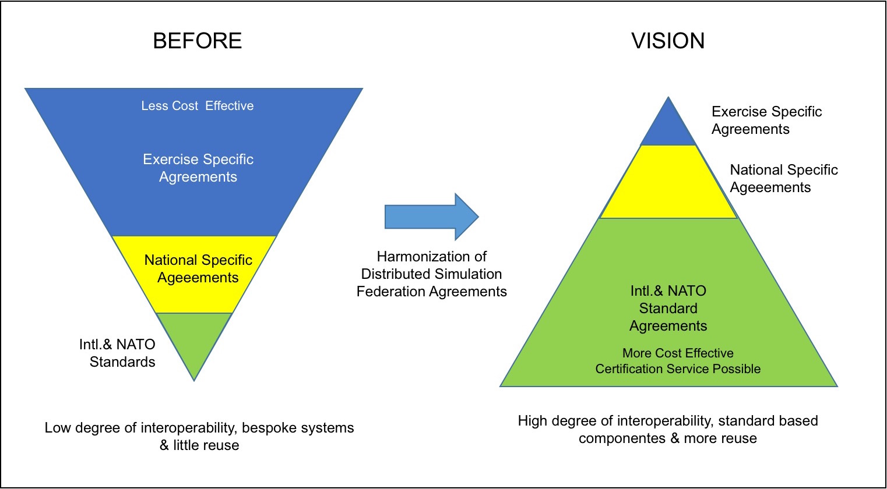
Figure 3-1: Increase Interoperability, Reuse, and Cost Effectiveness

Description of the Desired Changes
Following from the discussion of Section 4.1, the following is a list od desired outcomes:
- A formalized process and procedures for compliance testing and certification,
- Accreditation of test laboratories and certification entities,
- Tools to support Federation Agreement testing,
- Tools to support HLA IEEE 1516-2010 testing,
- Tools availability to support development, test and integration,
- Open source core for tools extendable by COTS vendors.

Priorities
Tools developed as part of MSG-134 will focus on the core testing engine and not user interface experience. The following areas of interoperability have been identified as priorities:
- STANAG 4603 (HLA Evolved) - HLA Compliance
- NETN Physical - federate's ability to produce and/or consume entity-state information to/from other federates in a federation
- NETN Warfare - federate’s ability to produce and/or consume events related to weapon firing, munition detonations and resulting effects on simulated models.
- NETN TMR - a federate’s ability to transfer and/or receive modelling responsibilities from other federates in the federation.
- NETN MRM - a federate’s ability to participate in a controlled aggregation and/or de-aggregation of simulated models.

Changes Considered but Not Included
The following areas of interoperability have been considered but are only partially addressed in the scope of work for MSG-134.
- Time Management Related interoperability requirements - synchronization of time, time-stamping, time-stamp-ordered data delivery etc.
- Fault & Performance related interoperability requirements - Managing Federate & Federation lost callbacks gracefully, Survivability in large federations (robustness)

Assumptions and Constraints
The current focus is HLA and specifically IEEE 1516-2010 and the assumption is that HLA will not be replaced in the near future.
Customers need to see the receipt of a compliance label for their products as a necessity. It might be assured in two ways; the first is to request at the NATO/National level to have a compliance label before any component is used for any training event, exercise, or experimentation effort. The second is to use a marketing strategy to challenge companies to get the highest available compliance label for their products.

CONCEPT OF THE PROPOSED SYSTEM

BACKGROUND, OBJECTIVES AND SCOPE
The NATO Simulation Interoperability Test and Certification Service is composed of tools and organizations that manage and deliver services for testing, verification, and certification of simulation components to enable efficient integration. These services must be self-sustaining, meaning there must be a business case with clear definitions of roles and responsibilities of the organizations involved. To be viable the proposed services must provide a benefit for customers. The main added value is the common understanding and description of NATO defined interoperability compliance.
The scope of interoperability certification provided by the system is wider than previous systems limited to HLA certification of primarily technical interoperability.

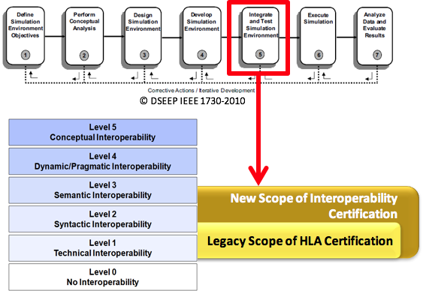
Figure 4-1 - New scope of interoperability certification

KEY ROLES
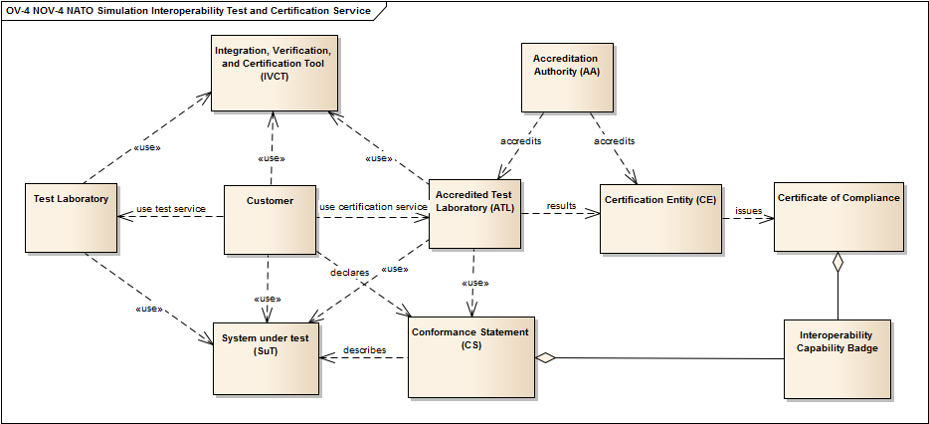
Figure 4-2: NOV-4 Organizational relationships and key roles
ANNEX A: Operating Procedures defines all identified roles and responsibilities in more detail.
All the following roles' responsibilities are defined for the FOC. The IOC responsibilities are the same but supported by a MSG-134 follow-on activity.

Accreditation Authority
The Accreditation Authority (AA) is a NATO appointed organization responsible for maintaining the business model and procedures used by Accredited Test Laboratories (ATL) and Certification Entities (CE).

Certification Entity
The Certification Entity (CE) is an organization accredited by the Accreditation Authority (AA) and given the authority to issue certificates of compliance to systems that have successfully undergone testing of Interoperability Requirements (IR). The CE is responsible for the management aspects of certification and is the initial point of contact for customers that want to certify their system (with the right to refuse the certification). The CE also maintains the official version of the Integration, Verification and Certification Tool (IVCT) and delivers it with the Executable Test Cases (ETC) to ATLs.

Accredited Test Laboratory
An Accredited Test Laboratory (ATL) is a Test Laboratory accredited by the Accreditation Authority (AA) and given the official authority to perform certification tests of Interoperability Requirements (IR) where the test results are recognized by the Certification Entity (CE) as valid for issuing certificates of compliance. The role of an ATL is to, upon request from a Customer, conduct certification tests on a System-under-Test (SuT) on behalf of a CE according to the business model defined by the AA. ATLs use the Integration, Verification and Certification Tool (IVCT) and Executable Test Cases (ETCs) provided by the CE to verify IRs associated with Capability Badges (CB) defined in the SuT Conformance Statement (CS). The CS is submitted by the Customer along with the SuT. The ATL delivers test results to the CE in a secure manner for official certification. ATLs continuously provide feedback on IVCT use to the CE and propose improvements to the test system and procedures. ATLs support the CE in maintenance tasks according to the business model set by the AA. ATLs collect IRs and proposed them to the AA for inclusion in the test suite.

KEY COMPONENTS
The NATO Simulation Interoperability Test and Certification Service consists of tools, organization and associated processes to deliver functional services related to test, verification, integration, and certification of interoperability capabilities, of simulation systems and components.
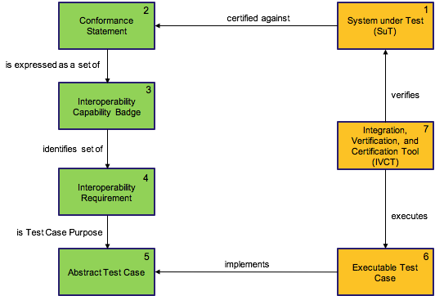
Figure 4-3: Key concept used in certification service

The System-under-Test (SuT) is certified against a Conformance Statement (CS) expressed as a set of Interoperability Capability Badges (CB) which identify the SuT Interoperability Requirements (IRs). Abstract Test Cases (ATCs) describe how the IRs are tested and these are implemented in Executable Test Cases (ETCs). The Integration Verification and Certification Tool (IVCT) uses ETCs to execute tests and to verify SuT compliance with IRs. A SuT that successful completes verification can receive a certificate and capability badges as tokens of interoperability compliance.

Interoperability Requirements
A Simulation Interoperability Requirement (IR) is related to how distributed systems interact and exchange information in order to collectively meet overall simulation objectives. IRs are specified to ensure that a system component can be easily combined, and interoperate with, other system components. The ability of a system to interoperate can be described as the set of fulfilled IR requirements.
Sets of related IRs can be defined and grouped to form Interoperability Capability Badges (CB) used to express a system’s capability to interoperate on a higher level than individual IRs.
IRs can also be grouped and associated with Abstract Test Cases (ATCs) as the implicit purpose of an ATC is to verify all associated IRs.
IRs can be grouped into categories:
ID | Name | Description
BP | Best Practice Conformance | Requirements related to best practices for distributed simulation
DOC | Documentation Conformance | Requirements for documenting interoperability capabilities
NETN | NETN Requirements | Requirements related to NETN FAFD, AMSP-04 Ed A, STANREC 4800
RPR2 | RPR2 Requirements | Requirements related to RPR-FOM v2.0
SOM | Simulation Object Model Conformance | Requirements related to the Conformance of a SuT to the SOM provided in a CS
Table 4-1: Categories of Interoperability Requirements

ANNEX B: Capability Badges, Interoperability Requirements and Abstract Test Cases define the initial set of interoperability requirements in more detail.

Abstract Test Case
An IVCT Abstract Test Case (ATC) is a complete, and implementation independent, specification of the actions required to verify a specific set of Interoperability Requirements (IR) associated with the ATC. This implies that the purpose of the ATC is to test all associated IRs.
The Certification Entity (CE) is responsible for defining the test case purposes (associating IRs with the ATC), and based on the purpose, specifying the test steps, actions, and valid responses & outcomes. Validation of an ATC against its test purpose is done by a CE.
A Test Case Developer (TCD) is contracted by a CE to implement Executable Test Cases (ETC) based on ATCs. These are scripts or compiled programs that can execute as part of IVCT. ETCs are verified by a CE and delivered to Accredited Test Laboratories (ATL) for use with the Integration, Verification and Certification Tool (IVCT).
MSG-134 has developed the first set of ATCs.
ID | Name | Description
CS-VERIFY | CS Verification | Verify conformance statement (CS) completeness and format.
FOM-DECODE | FOM Data Decoding Verification | Verify attribute and parameter value decoding conformance with the SOM specified in the CS.
FOM-ENCODE | FOM Data Encoding Verification | Verify attribute and parameter value encoding conformance with the SOM in the CS.
HLA-BEST | HLA Best Practices Verification | Verify use of HLA services and callbacks according to best practices.
HLA-DECLARE | HLA Declaration Management | Verify HLA declaration management services are used according to the CS.
HLA-OBJECT | HLA Object Management | Verify HLA object management services are used according to the CS.
HLA-SERVICES | HLA Services Verification | Verify use of HLA services and callbacks.
ATC-TMR-REQUEST-2016 | NETN TMR Request Test | Verify SuT compliant with NETN TMR Request Requirements
ATC-TMR-RESPOND-2016 | NETN TMR Respond Test | Verify the SuT complies with SuT requirements for responding to TMR.
ATC-TMR-TRIGGER-2016 | NETN TMR Trigger Test | Verify the SuT is compliant with NETN TMR Trigger Requirements.
RPR-PLATFORM | RPR Platform Testing | Verify the CS and GRIM requirements on RPR-Physical FOM Module attributes for platform and lifeform entities.
Table 4-2: First set of Abstract Test Cases

ANNEX B: Capability Badges, Interoperability Requirements and Abstract Test Cases define the initial set of ATCs in more detail.

Interoperability Capability Badges
An Interoperability Capability Badge (CB) is defined as a token of achievement for passing testing related to Interoperability Requirements (IR) associated with the CB. Successful compliance testing, verification, and certification of individual systems’ compliance with sets of IRs can be labelled using a CB representing this achievement.
The concept of using badges to indicate achievements is nothing new. It can be found in many domains from the scouts to the military. In on-line gaming, badges are frequently used to display an individual gamer's skill, accomplishments, and level of play. The semantics associated with badges and how they are used vary between different domains. Even within a single domain you can find different types of badges showing skill, quantitative and qualitative achievements, specific mission badges, and badges showing general maturity or level. Applying the badges concept to Interoperability Capabilities has been explored in research activities in the United Kingdom (UK) [CapBadge12] and [CapBadge15].
Achievement Graphs are used to specify dependencies between different CBs and to visualise road-maps for increased simulation component interoperability. E.g., Achieving RPR-ENTITY-2017 also requires achieving the HLA-BASE-2016 CB requirements. By using achievement graphs combinations/aggregations of CB associated IRs can be expressed.
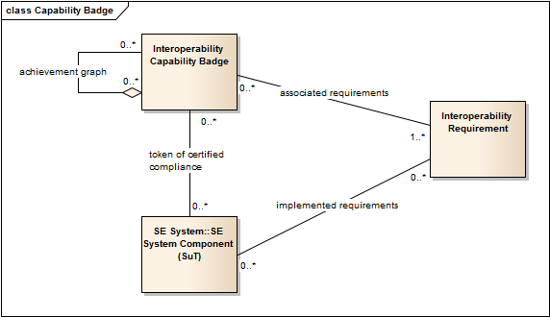
Figure 4-4: Relationships between the concepts of a CB, its associated IRs, and the System-under-Test

MSG-134 recommends the use of CBs as tokens for passing testing related to interoperability and as the basis for certificates of compliance. CBs are also used in the Conformance Statements (CS) provided by the SuT owners as the basis for certification.
A CB is identified by name, type and year. It has a short description and a graphical representation ("the badge"). The CB is defined by the set of associated IRs including references to Abstract Test Cases (ATC) describing how the IRs are verified.
The definition of CBs used in the NATO Simulation Interoperability Test and Certification Service is the responsibility of the Accreditation Authority (AA).
An initial set of CBs based on NATO Simulation Interoperability Test and Certification Service priorities have been defined:
ID | Dependency | Description
CWIX-DR-2017 | CWIX-ENTITY-2017 | Simulation Interoperability Compliance Badge for CWIX 2017
CWIX-ENTITY-2017 |  | Simulation Interoperability Compliance Badge for CWIX 2017
CWIX-WARFARE-2017 | CWIX-ENTITY-2017 | Simulation Interoperability Compliance Badge for CWIX 2017
HLA-BASE-2017 |  | Basic CS/SOM and Best Practices compliance
NETN-AGG-2017 | RPR-AGG-2017 | NETN-FOM v2.0 Aggregate FOM Module
NETN-ENTITY-2017 | RPR-ENTITY-2017 | NETN FOM v2.0 Physical FOM Module
NETN-LBML-INTREP-2017 | NETN-AGG-2017, NETN-ENTITY-2017 | NETN-FOM v2.0 LBML FOM Module
NETN-LBML-OWNSITREP-2017 | NETN-AGG-2017, NETN-ENTITY-2017 | NETN-FOM v2.0 LBML FOM Module
NETN-LBML-TASK-2017 | NETN-AGG-2017, NETN-ENTITY-2017 | NETN-FOM v2.0 LBML FOM Module
NETN-MRM-2017 | NETN-TMR-2017 | NETN FOM v2.0 MRM FOM Module
NETN-TMR-2017 | HLA-BASE-2017 | Basic support for NETN TMR pattern (AMSP-04 Ed A). SuT is able to respond to TMR requests.
RPR-AGG-2017 | HLA-BASE-2017 | RPR-FOM v2.0 Aggregate FOM Module
RPR-ENTITY-2017 | HLA-BASE-2017 | RPR-FOM v2.0 Physical FOM Module support. GRIM compliance wrt. Platforms, Lifeforms etc. representation of required attributes.
RPR-WARFARE-2017 | HLA-BASE-2017 RPR-ENTITY-2017 | RPR-Warfare v2.0 FOM Module support.
Table 4-3: Initial set of Capability Badges

ANNEX B: Capability Badges, Interoperability Requirements, and Abstract Test Cases define the initial proposed set of interoperability capability badges in more detail.

Conformance Statement
A Conformance Statement (CS) is a written statement declaring a systems' compliance with identified Interoperability Requirements (IRs). A CS is provided by the owner of a System-under-Test (SuT) to identify which standard sets of IRs the SuT should be certified against. In the CS the sets of IRs are referenced as Capability Badges (CB).
A CS shall include the following information:
- Metadata including SuT identification, date and POC information
- A Simulation Object Model (CS/SOM) (if SuT creates multiple federates each need to be described in separate CS and are tested individually)
  - the SOM must contain the complete list of HLA services used
- A Federation Object Model (CS/FOM)
- Identified set CBs to test against
  - Additional CS information and parameters as required by CB
ANNEX C: Conformance Statement, defines the CS template in more detail.

Integration Verification and Certification Tool (IVCT)
The NATO Simulation Interoperability Test and Certification Service Integration, Verification and Certification Tool (IVCT) is a core technical framework provided by Certification Entity (CE) and used to support test and verification of simulation interoperability requirements. The IVCT is used to for testing of individual simulation components interoperability capabilities and to support integration of distributed simulations. Accredited Test Laboratories (ATL) use the IVCT to perform certification testing.
The IVCT is a component based software package with modules supporting scheduling, execution and reporting of results from running Executable Test Cases (ETC).
ETCs are implementations of Abstract Test Cases (ATC) developed to verify defined sets of Interoperability Requirements (IR).
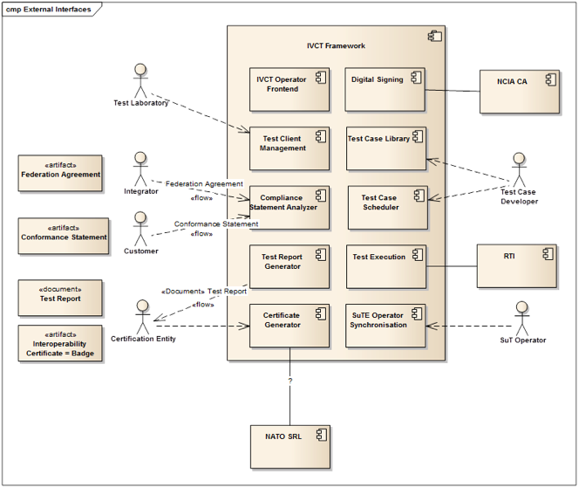
Figure 4-5: Major IVCT modules
The IVCT executes in a HLA federation together with the System-under-Test-Environment (SuTE) consisting of the System-under-Test (SuT) and other auxiliary federates and systems. The IVCT Test Engine (TE) run ETCs to stimulate and to check responses from the SuT. Results are reported by the IVCT as successful or unsuccessful verification of IRs.
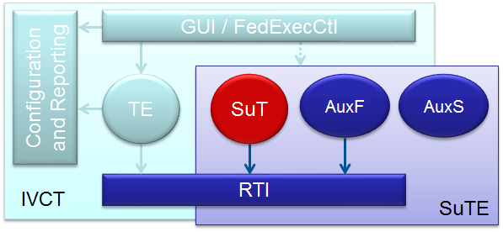
Figure 4-6: Using IVCT
MSG-134 have implemented a first version of IVCT including core TE and supporting modules. The IVCT is implemented and provided as Open Source and is maintained by CE.
ANNEX D: Integration, Verification and Certification Tool defines the IVCT operational requirements in more detail.

Information available to the public via the CE website
Procedures and processes about the flow of the certification will be displayed in a specific page of the CE portal as well as the advantage of having tools NATO certified.
There will be a login form for starting the accreditation procedures and detailed explanation on fee amount.
Once the Customers are appropriately registered on the CE Portal, it will be ensured the possibility to download the latest IVCT version (which will be released for free), as well as the needed ETC through a dedicated download area.
CE will maintain a dedicated page on which issued certificates will be published with the permission of the SuT owner.
Indications on H/W, S/W and network requirements will be provided in the CE Portal

OPERATIONAL SCENARIOS
Operational Scenarios and Use Cases define the operational procedures of all identified roles that are needed to fulfil their respective responsibilities and to comply with operational policies and constraints.
More detailed descriptions of operational scenarios and use-cases can be found in ANNEX A: Operating Procedures.

ACCREDITATION AND CERTIFICATION
The following diagram shows the details of the Certification Service as a Use Case (UC). There are basically two loops in this service. The first (on the right side of the diagram) is the accreditation phase, where the Certification Entity and the Test Laboratory must be accredited by the Accreditation Authority. The second loop (on the left side of the diagram) is the certification process for a System under Test.
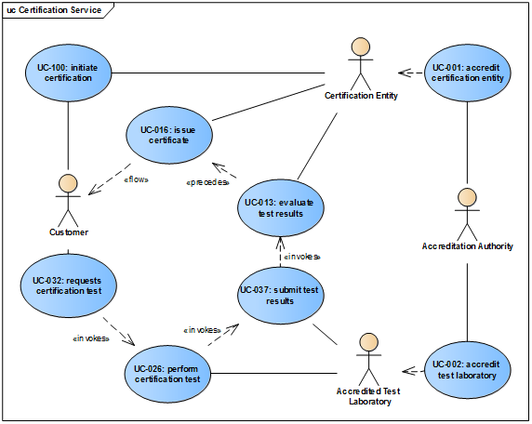
Figure 5-1: Use Case of Certification Service

Title | Description
UC-001 Accredit Certification Entity | The AA receives a CE accreditation request from a CE candidate organization. The AA checks whether the CE candidate meets defined CE requirements, including organizational and security standards. If the CE candidate complies with all CE requirements the AA will accredit the CE candidate. Otherwise the reasons for non-compliance will be provided to the CE candidate.
UC-002 Accredit Test Laboratory | The AA receives an accreditation request from an ATL candidate to conduct certification testing. The AA checks whether the ATL candidate meets defined ATL requirements including organizational, technical, and security. If the ATL candidate complies with all ATL requirements the AA will accredit the ATL candidate. Otherwise the reasons for non-compliance will be provided to the ATL candidate.
UC-013 Evaluate Test Results | A Certification Entity will evaluate the results according a predefined procedure to determine whether the System under Test has me the requirements needed to merit a Conformance certificate.
UC-016 Issue Certificate | The Certification Entity, upon successful evaluation of the test results, will issue a certificate to the Customer.
UC-026 Perform Certification Test | The ATL analyzes the SuT CS, and based on the requested CBs, selects and configures appropriate ETCs and sets-up the IVCT. The ATL runs the IVCT test system using the configuration derived from the SuT CS.
UC-032 Requests Certification Test | The Customer contacts an ATL to arrange for certification testing. The Customer negotiates the conditions for the SuT certification test with the ATL. The Customer submits the SuT, SuTE and CS to the ATL.
UC-037 Submit Test Results | The Accredited Test Laboratory will submit the results of a certification test via a secure transport mechanism to the Certification Entity.
UC-100: Initiate Certification | The Customer initiates the certification process by contacting a CE and providing a request for certifying the SuT against a CS. The CE informs the Customer which ATLs are able to perform the tests required by the CS.
Table 5-1: Use cases related to Certification Service

ACCREDITATION PROCESS OF A CANDIDATE FOR THE ATL ROLE
Not defined by MSG-134 for IOC.

ACCREDITATION PROCESS OF A CANDIDATE FOR THE CE ROLE
The candidate for the CE Role must be an organization, NATO accredited, that needs to show its capability in performing the related roles detailed in Annex A and will be evaluated by a dedicated team issued by the Accreditation Authority.

DEVELOPMENT AND MAINTENANCE
The following diagram shows the various developer roles involved in implementing the test tool software. This includes the implementation of the test tool, the test cases, and the management system, as well as their maintenance and documentation.
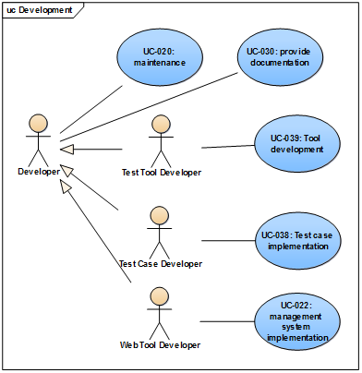
Figure 5-2: Use Case of Development

Title | Description
UC-020 Maintenance | The test tool requires maintenance due to issues with the tool or test cases, operating system changes, enhancements, as well as changes in the pattern specifications, or interpretation of the pattern specifications.
UC-022 Management System Implementation | The Management System will manage the documents and data files related to a certification test. These files will be stored in an online database such as NSRL. This system must guarantee the files are transferred and stored in a secure manner to prevent tampering with, or unauthorised disclosure of, the contents. The files will be accessed via Web Services.
UC-030 Provide Documentation | A Developer must provide documentation for the development, maintenance and enhancement of the test tool. Since even a minor change can cause incompatibilities, it is necessary to know exactly the tool behaviour in each version.
UC-038 Test Case Implementation | The Certification Entity is responsible for defining the test case purposes. The abstract test cases (specifying the test steps and allowable reactions) are created by the Certification Entity, based on the test purposes. The validation of the abstract test cases against the test purposes is also done by the Certification Entity. Test purposes are specified by implementation pattern protocol experts and these are implemented by Test Case Developers into executable test cases. Usually executable test cases will use a test case library to handle bundled events or other support functions. The log files can be examined and checked against the test purposes to prove the valid implementation of the test cases. The Test Case Developer implements the executable test cases from the abstract test cases. The executable test cases are compiled programs using the IVCT Application Programming Interface (API). The work done by the Test Case Developer also includes the verification of the executable test cases against the abstract test cases as well as the long-term maintenance of the test cases.
UC-039 Tool Development | Test Tool development will take place only after a design specification is created. Several test tool developers may work on various well-designed independent modules. When the test tool has reached a significant level of quality and maturity, and has been employed in certification test and accepted by the CE, it will be considered to be in the maintenance phase.
Table 5-2: Use cases related to Development

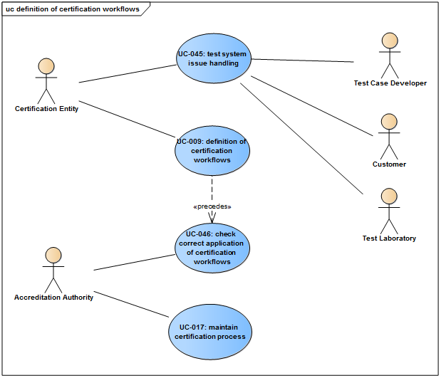
Figure 5-3: Definition of certification workflow Use Case Diagram

Title | Description
UC-009 Definition of Certification Workflows | The Certification Entity will define procedures for all the roles in the Certification Workflow. The workflow must include the practical needs of a certification test as well as the security needs for secure report management and Customer confidentiality. The Customer must be informed of his role when contacting a CE. All other roles must be defined and known for a Test Laboratory to be accredited.
UC-017 Maintain Certification Process | The AA updates and maintains a documented certification process including CE and ATL operational requirements and criteria for accreditation.
UC-045 Test System Issue Handling | An Issue Handling System is an important part of any Test System, since when a change is made it may invalidate previous results. All issues, and any changes or rejections, of these issues must be recorded. Through use of an issue tracking system the status of the test system and test case interpretations at any point in time is known. The quality of the test system is improved when issues are properly tracked and resolved.
UC-046 Certification Workflow Compliance Review | The AA evaluates the conformance of CEs and ATLs with certification processes and operational requirements on a regular basis. The AA provides CEs with updated ATL status and contact information.
Table 5-3: Use cases of Verification Workflow

SUMMARY OF IMPACTS
NATO and Partners certification of simulation components' interoperability capability will have a major impact on how interoperability requirements are expressed and tested for new simulation components, and for the integration of federated distributed simulations.
The way systems are procured, integrated and tested will change when:
- Simulation components are required to conform with NATO standards,
- NATO simulation interoperability certification services must be used as part of the delivery process,
- NATO certificates of simulation interoperability compliance are in place for existing systems.
To include the use of NATO services for certification:
- Acquisition organizations and authorities will need to understand the benefits of using NATO certified simulation components,
- Procurement processes may have to be adapted to include the use of NATO services for certification.
In order for a simulation component to be accepted as part of a federated distributed simulation system:
- Simulation interoperability requirements should be specified in accordance with NATO standards,
- Vendors should be required to undergo certification or provide proof of compliance.
The availability of common tests, and free tools, for interoperability test and verification will also have a major impact by allowing COTS, GOTS, and other system developers to pre-test their systems and to perform self-certification to some extent. This will reduce the risks and costs associated with solving interoperability issues during integration.

ANALYSIS OF THE PROPOSED SYSTEM
An analysis of the proposed system has been made to identify and make visible any strengths, weaknesses, opportunities and threats.
 | Helpful | Harmful
Internal | Strengths  - Definition of standard procedures  - Initial experience and knowledge of earlier certification tools (FCTT)  - Good representation of stakeholders in group | Weaknesses  - No clear/aligned budget  - Unbalanced contribution  - Limited focus/restricted to HLA certification  - Unclear business process
External | Opportunities  - Integration cost reduction  - Integration risk reduction  - Reduction integration time  - Increased market for interoperable simulation components  - Aligned parallel activities (reuse)  - Enforce use of STANAG 4603 | Threats  - Market might be too small to sustain maintenance  - Market moves in another direction  - Resistance to adoption  - Non-aligned parallel activities (redundancy)
Table 7-1: Analysis results of certification service

BUSINESS MODEL

BUSINESS OF CERTIFICATION ACTIVITY
Nations participating in MSG-134 have designed and developed IVCT version 1.0. The NMSG delivered this version to the CE which is responsible for maintenance of the IVCT.
ATLs will provide feedback on IVCT to the CE. The CE maintains the list of IVCT requirements and gets approval from the AA for IVCT updates. The CE may conduct updates itself or participate in collaborative efforts initiated by the AA.
MSG-134 has developed the first set of Abstract Test Cases and corresponding Executable Test Cases. The AA is responsible for managing all Capability Badge definitions and prioritization. The CE is responsible for abstract and executable test case development. The AA supports the CE by providing SME contacts to help define abstract test cases for particular badge/interoperability requirements.
The primary customers of certification services and use of the IVCT have been identified as:
- NATO organizations and NATO partner nations' government organizations providing certification services,
- Procurement agencies and supporting organizations for acquisition of distributed simulation systems,
- Simulation System Integrators (10-50 NATO wide),
- Simulation System Developers (50-100 COTS/GOTS vendors willing to certify their systems).
It is hard to estimate the exact size of the market for the proposed system. The market for the IVCT is substantially larger than the certification service since it can be used by any simulation system developer and integrator in many contexts.
The 28 NATO nations and 42 partner nations are the primary stakeholders of the certification service. The number of systems used and integrated in these nations to support activities (e.g. training and exercises) will define the level of utilization of the certification service. Based on existing certification services provided, we estimate that a fully-functional and operational service will conduct 10-20 certifications per year. Initial operating capability (IOC) is estimated to conduct 5-10 certifications per year.
IOC is expected to include a single ATL, with 5-10 customers, conducting interoperability tests and verification for an average of 7 Capability Badges per customer.
MSG-134 proposes one option for a business model to fund development and maintenance of the Certification Service Process and Tools: A customer funded business model with income streams to cover the cost of the certification process.

CUSTOMER FUNDED BUSINESS MODEL

Early development (2015-2017)
During the duration of MSG-134, the business model applied was the following: Nations participating in MSG-134 fund the efforts of the IVCT and succeeded in developing version 1.0 of the IVCT, as well as developing some ETCs.

Initial Operational Capability (2018-2020)
During this period, MSG-134 suggests to continue the previous business model of having participating nations of the MSG-134 follow-on activity fund the continued development of the IVCT and ETCs.
The follow-on of MSG-134 will act as the ATL and the NATO M&S COE will act as the CE during this period.
Certification for the customer will be free of charge during this period.

Fully Operational Capability (2021 and beyond)
During this period, ATLs will be established and the NATO M&S COE continues to act as the CE.
IVCT maintenance and ETC development will be funded by:
- A yearly fee defined by the AA, paid by the ATLs to the CE for the maintenance of the IVCT;
- Fees paid by the customer to the ATLs on the basis of the specific CB requested. Part of this fee will be transferred to the CE for further development of the IVCT and for development of new ETC as needed and agreed by the AA.
The AA together with the CE defines the fee for Badge Certificates paid by ATLs to CE.
ATLs will be responsible for establishing the cost of certification testing for their customers.
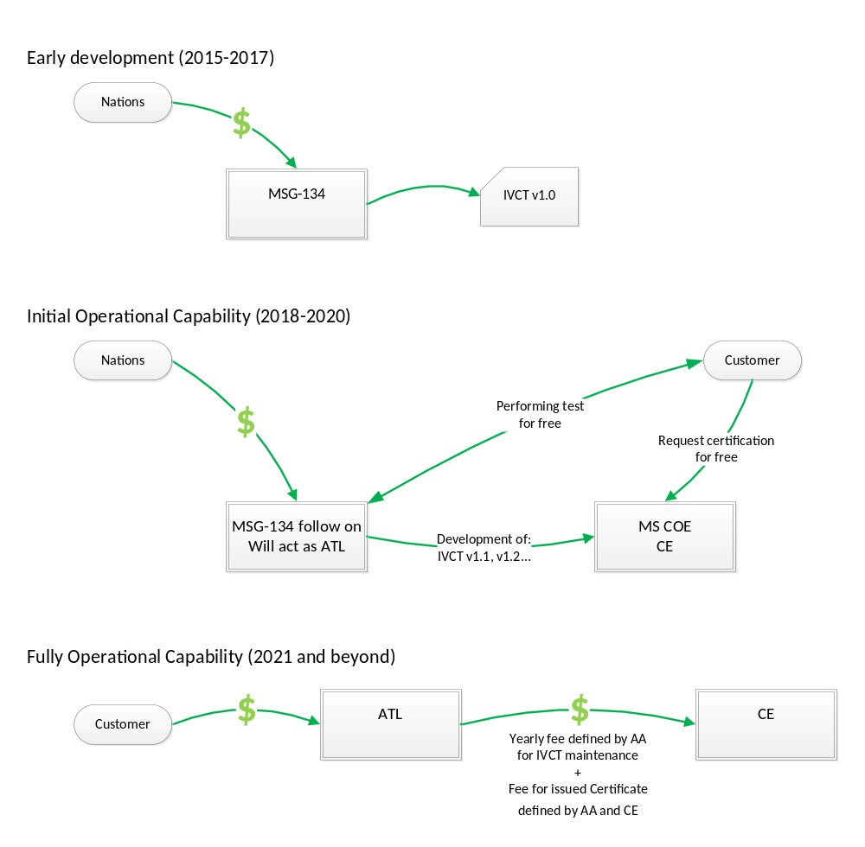
Figure 8-1: Funding of IVCT and Certification Service

PROPOSED ORGANIZATION
The Initial Operating Capability (IOC) organization to support NATO Simulation Interoperability Testing and Certification can be limited in size, with few resources manning the organization. Initially a single ATL is envisioned with a limited number of certifications. However, the proposed organizational structure has been designed to support a growing market and demand for test and certification services in a scalable manner.
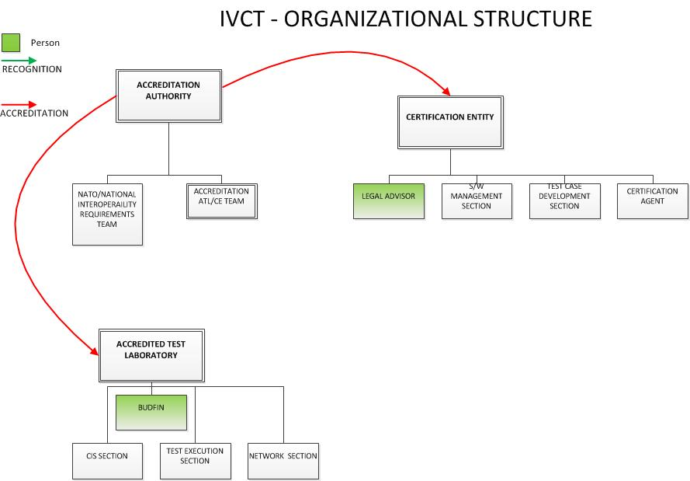
Figure 8-2: Proposed Organizational structure
The following IOC allocation of responsibilities is recommended:
- The AA is NMSG; a candidate is MS3, if the group includes the M&S NATO entities (JFTC, JWC, M&S COE).
- The CE is the NATO M&S CoE.
- Initial ATL activity could be supported by the members of the MSG-134 Follow-on group.

STRATEGY FOR INITIAL OPERATIONAL CAPABILITY
The IOC will create the conditions for establishing the processes and procedures, and gaining broad audience acceptance.
- MSG-134 has created the initial IVCT, certification processes and procedures, and the first set of abstract and executable test cases.
- MSG-134 has created marketing materiel and will continue an information campaign to create demand for certification services, and to make government, and procurement agencies aware of these capabilities. Activities include:
  - CWIX 2016, 2017 participation
  - Marketing at CD&E Conference, CAX Forum, ITEC/IITSEC etc.
- MSG-134 will promote use of tools and services, and establish IOC with NMSG acting as the AA and the NATO M&S CoE acting as the CE.
- MSG- 134 will identify and engage the initial ATL.
- The NATO M&S CoE (CE) will assume responsibility for IVCT maintenance.
- Acting as the AA, MSG -134 will evaluate and continue to promote capability.
- Final Operational Capability (FOC) is planned for 2020.

BUSINESS MODEL FOR THE TRANSITION PERIOD FROM IOC TO FOC
- The follow on activity will support the following entities: ATL, the NATO M&S CoE as the CE, and MS3 as the AA.
- The yearly fee charged to the ATL is zero, but the ATL is expected to participate to the follow up activity by contributing to the development and maintenance of the IVCT and test cases.

OWNERSHIP OF THE IVCT, ABSTRACT TEST CASES, AND EXECUTABLE TEST CASES
IVCT is an open source product initially developed by the MSG 134 and owned by the AA. It will be available to the ATLs and other test laboratories through the CE website once the stable version is delivered to the CE; no later than the end of the MSG 134 mandate.
Abstract test cases and executable test cases verified by the CE and approved by the AA will be shared with ATLs. Sharing of non-approved test cases is the responsibility of the owner.
The AA defines and prioritizes the development of ATCs and ETCs based on the IRs.

REFERENCED DOCUMENTATION

Ref | Identification
[AMSP-01] | AMSP-01 NATO MODELLING AND SIMULATION STANDARDS PROFILE Edition C Version 1 MARCH 2015
[AMSP-04] | AMSP-04 NATO Education and Training Network (NETN) Federation Agreements and FOM Design (FAFD) Edition A Version 1 (DRAFT)
[CapBadge15] | Visualisation and Discovery of Systems’ Interoperability Capability using ‘Capability Badges’ and ‘Achievement Trees’. Final Report SE Tower TC1 AIMS Task 3 Novel Approaches. 2015-06-05.
[CapBadge12] | Capability classification and automated test procedures. Final Report DSTLX10000079012. CDE30665
[CONOPS15] | NATO Simulation Certification Service CONOPS. Annex A of MSG-134 Technical Report.
[MSG134TAP] | MSG-134 Technical Activity Proposal (TAP). NATO Modelling and Simulation Group. NATO Science and Technology Organization
[IEEE1516-2010] | IEEE 1516-2010 - IEEE Standard for Modelling and Simulation (M&S) High Level Architecture (HLA) - a.k.a HLA Evolved
[IEEE1730] | IEEE 1730-2010. Distributed Simulation Environment Engineering Process (DSEEP).
[IEEE830] | IEEE 830-1998. IEEE Recommended Practice for Software Requirements Specifications. ISBN 0-7381-0332-2
[Lofstrand & Hodicky 2015] | Björn Löfstrand, Jan Hodicky. NATO Distributed Simulation Architecture & Design, Compliance Testing and Certification - MSG-134. 10th NATO CAX Forum 2015. September 2015
[Tolk03] | Tolk, A. and Muguira, J.A. (2003). The Levels of Conceptual Interoperability Model (LCIM). Proceedings IEEE Fall Simulation Interoperability Workshop, IEEE CS Press
[FAFD15] | NATO Education and Training Network (NETN) Federation Agreements and FOM Design (FAFD) v2.0. NATO Modelling and Simulation Standards Subgroup (MS3)
[STANAG4603] | STANAG 4603 Ed. 2 (2015) Modelling And Simulation Architecture Standards For Technical Interoperability: High Level Architecture (HLA). NSO(AC/323)0234 (2015) NMSG/4603.
[NATO09] | Strategy for the use of Open Source Software in NATO Systems. NATO Document AC/322-D(2009)0015, 16 March 2009
[NATO15] | NATO Software Management Policy. NATO Document AC/322-N(2014)0119, 2 February 2015

OPERATING PROCEDURES

ROLES AND RESPONSIBILITIES
The main operational roles in the NATO Simulation Interoperability Test and Certification Service are the Accreditation Authority, the Certification Entity, Accredited Test Laboratories, and the Customer. The responsibilities of these roles are defined by operation requirements. Procedures and activities associated with each role are defined by operational use-cases.
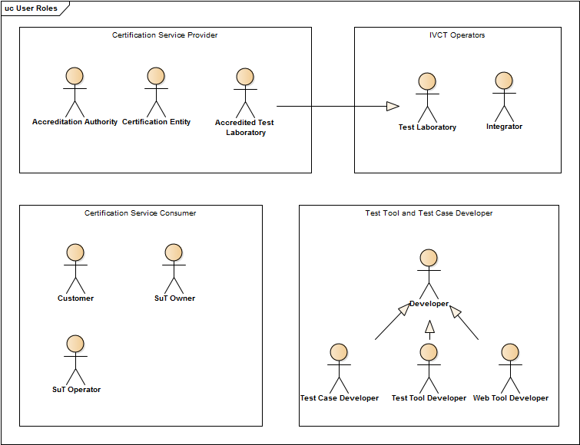
Figure A-1: NOV-2 User Roles

Accreditation Authority
The Accreditation Authority (AA) is a NATO appointed organization responsible for maintaining the business model and procedures used by Accredited Test Laboratories (ATL) and Certification Entities (CE).

Initial Operational Requirements
ID | Description
OR-AA-0001 | The AA shall maintain procedures for accreditation of CEs and ATLs including the maximum time-period to be accredited.
OR-AA-0002 | The AA shall perform accreditation of CEs within the time period specified in the accreditation procedure.
OR-AA-0003 | The AA shall perform accreditation of Test Laboratories within the time period specified in the accreditation procedure.
OR-AA-0004 | The AA shall collect IRs from CEs and set priorities according to the NATO certification strategy.
OR-AA-0005 | The AA shall define the list of approved NATO Capability Badges, in relation of prioritized IRs.
OR-AA-0006 | The AA shall provide contact information of experts to the CE to assist with the definiion, development, and implementation of abstract test cases.
OR-AA-0007 | AA shall maintain the IVCT requirement specifications
Table A-1: Initial operational requirements of Accreditation Authority

Operational Use Cases
Title | Description
UC-001 Accredit Certification Entity | The AA receives CE accreditation requests from CE candidate organizations. The AA determines if the CE candidate meets defined CE requirements, including organizational and security standards. If the CE candidate complies with all CE requirements the AA will accredit the CE candidate, otherwise the reasons for withholding accreditation will be provided to the candidate.
UC-002 Accredit Test Laboratory | The AA receives an accreditation request from an ATL candidate to conduct certification testing. The AA checks whether the ATL candidate meets defined ATL requirements including organizational, technical and security aspects. If the ATL candidate complies with all ATL requirements the AA will accredit the ATL candidate, otherwise the reasons for non-compliance will be provided to the ATL candidate.
UC-017 Maintain Certification Process | The AA updates and maintains the documented certification process including CE and ATL operational requirements, and criteria for accreditation.
UC-046 Certification Workflow Compliance Review | The AA evaluates the conformance of CEs and ATLs with the certification process and operational requirements on a regular basis. The AA provides CEs with updated ATL status and contact information.
Table A-2: Use cases related to Accreditation Authority

Certification Entity
The Certification Entity (CE) is an organization accredited by the Accreditation Authority (AA) and given the authority to issue certificates of compliance to systems that have successfully undergone certification testing against interoperability requirements (IR). The CE is responsible for the management aspects of certification and is the initial point of contact for customers that want to certify their system (customers have the right to refuse the certification). The CE also maintains the official version of the Integration, Verification, and Certification Tool (IVCT) and delivers it and executable test cases to ATLs.

Operational Requirements
ID | Description
OR-CE-0001 | The CE shall confirm ATL submission of certification test results within one week.
OR-CE-0002 | The CE shall process certification test results and deliver certification result within time specified by contract.
OR-CE-0003 | The CE shall store certification test results in a secure environment.
OR-CE-0004 | The CE shall provide a central point of contact for all certification services.
OR-CE-0005 | The CE shall provide a Web-Based information system for certification service users.
OR-CE-0006 | The CE shall provide an IVCT and ETC issue tracking system.
OR-CE-0007 | The CE shall provide IVCT configuration management and up-to-date software status information to ATLs
OR-CE-0008 | The CE shall evaluate and correct irregular IVCT and ETC software behaviour as soon as possible.
OR-CE-0009 | The CE shall define a procedure for releasing new versions of the IVCT software.
OR-CE-0010 | The CE shall provide a test environment for verifying the IVCT software before release.
OR-CE-0011 | The CE shall manage all IVCT software contributions.
OR-CE-0012 | The CE shall, with SuT owner permission, publish certificates.
OR-CE-0013 | The CE shall provide IVCT software on request to SuT owners and test laboratories.
Table A-3: Operational requirements of Certification Entity

Operational Use Cases
Title | Description
UC-003 Archive and Remove Test Results | Once the Test Results have been sent to the Certification Entity, they should be archived in a dedicated repository and deleted from the storage where they were generated. The Test Results are the most important information for determining if a certificate should be awarded and care should be taken against any manipulation of these results. The test results should not be made viewable by any customer other than the one that provided the SuT. The test results should be stored in a secure location with access by authorized personnel only.
UC-006 Define Abstract Test Case | Once the test purposes have been defined, it is possible to define the steps required to achieve these purposes in the form of abstract test cases. Abstract Test Cases are the sequences of requests and expected responses independent of a programming language.
UC-007 Define Test Purpose | When a pattern protocol is defined, it is a good idea to define Test Purposes which will constitute a comprehensive test of the functionalities and variations of these functionalities. As far as possible the Test Purposes should also cover error handling invalid behaviour.
UC-009 Definition of Certification Workflows | The CE will define the procedures for the roles of all participants of the certification workflow. The workflow must include the practical needs of a certification test as well as the security needs of secure report management and customer confidentiality. The customer must be informed of his role when contacting the CE. All other roles must be defined and known for a test laboratory to be accredited.
UC-013 Evaluate Test Results | A certification entity will evaluate the results according a predefined procedure to determine whether the SuT has shown sufficient capabilities to merit a conformance certificate.
UC-016 Issue Certificate | The certification entity, upon successful evaluation of the test results, will issue a certificate to the customer.
UC-018 Maintain Test Cases | During the course of testing implementations, various issues may occur that require changes to test cases. This maintenance activity should be done in a disciplined manner, since even small changes could invalidate previous test certificates. After a change to any test cases, the test cases should be run against SuT from two different SuT developers to test for side effects. All changes must be documented in respect to an issue and its solution.
UC-019 Maintain Test System | Whenever the IVCT is used an issue may occur that requires a modification or extension to the system. A change to any test cases may invalidate test results and should be handled very carefully. Each issue should be well documented and the software should be checked in to a source control system after each modification.  The certification entity must review the changes before authorizing a new Test Tool release.
UC-020 Maintenance | The IVCT requires maintenance due to issues with the tool or test cases, operating system changes, enhancements, as well as changes in the pattern specifications or interpretation of the pattern specifications.
UC-021 Manage Test Case Results | The results of the execution of the ETCs are saved in a safe manner, sent to the CE and to the Customer. Results are logging files for the executed tests and a summary with the ETC verdicts.
UC-031 Publish Certification Result | After receiving permission from the federate owner, the CE will publish the certification test result.
UC-037 Submit Test Results | An ATL will submit the results of a certification test via a secure transport mechanism to the Certification Entity.
UC-040 Validate Test Case | Once an abstract test case is created, it should be checked to confirm it is a valid interpretation of the test purposes. The CE should make sure this is completed before executable test cases are created.
UC-045 Test System Issue Handling | An issue handling system is an important part of any test system, since when a change is made it may invalidate previous results. All issues and any changes or rejections of these issues must be recorded so that the status of the test system and test case interpretations at any point in time is known. The quality of the test system is improved when issues are properly resolved.
UC-046 Certification Workflow Compliance Review | The AA evaluates the conformance of CEs and ATLs with the certification process and operational requirements on a regular basis. The AA provides CEs with updated lists providing ATL status and contact information.
UC-050 Secure Access and Archive | The Test Results should not be made viewable to any other Customers than the Customer who provides the SuT. The Test Results should be stored in a secure location with access by authorized personnel only.
UC-051 Secure Transportation Mode | A CE will receive test results from an ATL via a secure transportation mode.
Table A-4: Use cases related to Certification Entity

Accredited Test Laboratory
An Accredited Test Laboratory (ATL) is a test laboratory accredited by the accreditation authority (AA) and given the official authority to perform certification tests of interoperability requirements (IR) and whose test results are recognized by Certification Entitys (CE) as valid for issuing certificates of compliance. The role of an ATL is to conduct certification tests at the request of a customer on the customer’s System-under-Test (SuT) on behalf of a CE according to the business model defined by the AA. ATLs use the Integration, Verification and Certification Tool (IVCT) provided by CEs and run Executable Test Cases (ETC) (also provided by CEs) to verify IRs associated with Capability Badges (CB) defined in the SuT Conformance Statement (CS) submitted by the Customer. An ATL delivers test results to a CE in a secure manner for official certification. ATLs continuously provide feedback on IVCT use to the CE and propose improvements to the test system and procedure. ATLs supports the CE in maintenance tasks according to the business model set by the AA. ATLs collect IRs and propose them to the AA for inclusion in new CBs.

Operational Requirements
ID | Description
OR-ATL-0001 | Each ATL shall define its terms and conditions for providing the certification test service.
OR-ATL-0002b | The ATL certification service may be performed at customer site.
OR-ATL-0003 | An ATL shall comply with agreed Customer security requirements.
OR-ATL-0004 | An ATL shall safely transfer certification test results to the CE, using the security protocol established by the CE.
OR-ATL-0005 | An ATL shall provide a capability to backup test results.
OR-ATL-0006 | An ATL shall store certification test results in a secure manner.
OR-ATL-0007 | An ATL shall only allow access to certification test results by authorised personnel.
OR-ATL-0008 | An ATL shall ensure that certification test results cannot be manipulated after certification test has finished.
OR-ATL-0009 | An ATL shall report irregular IVCT software behaviour to the CE.
OR-ATL-0010 | An ATL shall only use the latest released ETC versions, provided by the CE, for certification testing.
OR-ATL-0011 | An ATL shall ensure that only SuTE components are connected to IVCT during testing.
OR-ATL-0012 | An ATL should allow customers to choose to submit, or not, their SuT test results for certification.
Table A-5: Operational requirements of Accredited Test Laboratory

Operational Use Cases
Title | Description
UC-004 Configure Network Infrastructure | In the case of a LAN, the network addresses have to be configured and the ports have to be opened. In case of a WAN, further routing and forwarding may have to be configured. This task requires knowledge of networking by both the ATL and the customer.
UC-011 Evaluate CS | The ATL will evaluate the CS pertaining to the SuT and select the relevant ETC(s) to be executed.
UC-014 Execute Test Cases | The selected Test Cases are run against the SuT and the results of the test are recorded.
UC-019 Maintain Test System | Whenever the Test Tool is used an issue may occur that requires a modification or extension to the system. A change to any test case may invalidate test results and should be handled very carefully. Each issue should be well documented and the software should be checked in to a source control system after each modification.  The CE must review the changes before authorizing a new test tool release.
UC-021 Manage Test Case Results | The results of the execution of ETCs are saved in a secure manner and sent to the CE and the customer. Results are log files for the test execution and a summary with the ETC verdicts.
UC-026 Perform Certification Test | The ATL analyses the SuT CS and, based on requested CBs, selects and configures appropriate ETCs and sets-up the IVCT. The ATL runs the IVCT test system using the SuT CS.
UC-028 Perform Test | Run the IVCT test System using the conformance statement of the SuT to select the appropriate test cases. The IVCT operator may select the mode (integration, verification or certification) in which the test system should operate. These modes are realized by specific test cases designed for the mode.
UC-029 Perform Verification Test | The ATL will run the verification test against the SuT using the procedures defined. The SuT may require a specific environment (SuTE) for its operation.
UC-032 Requests Certification Test | A customer contacts an ATL to arrange for certification testing. The customer negotiates the conditions of the certification test with the ATL. The customer submits SuT, SuTE, and CS to the ATL.
UC-037 Submit Test Results | The ATL will submit the results of a certification test via a secure transport mechanism to the CE.
UC-045 Test System Issue Handling | An issue handling system is an important part of any test system, since when a change is made it may invalidate previous results. All issues and any changes or rejections of these issues must be recorded so that the status of the test system and test case interpretations at any point in time is known. The quality of the test system is improved when issues are properly resolved.
UC-047 Operate IVCT | The IVCT operator uses the IVCT test system to test a SuT. The operator needs to have sufficient knowledge to configure, start, operate, and stop the test system.
Table A-6: Use cases related to Accredited Test Laboratory

Customer
A Customer of the NATO Simulation Interoperability Test and Certification Service is either a system owner or has obtained the rights from the system owner to initiate certification testing of the system. The customer initiates the certification process by contacting the Certification Entity (CE) and by providing a request for certifying the System-under-Test (SuT) against a Conformance Statement (CS).

Operational Requirements
ID | Description
OR-CUSTOMER-0001 | The customer shall provide the System-under-Test Environment (SuTE) to the ATL if required by the SuT to correctly operate during testing.
OR-CUSTOMER-0002 | The customer shall identify the SuT Owner when initiating certification.
Table A-7: Operational requirements of Customer

Operational Use Cases
Title | Description
UC-032 Requests Certification Test | The customer contacts an ATL to arrange for certification testing. The customer negotiates the conditions for the SuT certification test with the ATL
UC-033 Self-Testing | A customer can use the IVCT at any time to aid in developing their SuT, and as a final check before submitting it for certification testing.
UC-034 Submit CS | The customer submits a Conformance Statement (CS) with basic info about the SuT and the Capability Badges (CB) to be certified against. The CS provides the basis for test case selection.
UC-035 Submit SuT | The Customer provides the SuT as an executable according to ATL requirement.
UC-100: Initiate Certification | Customer initiates the certification process by contacting CE and by providing a request for certifying the SuT against a CS. CE informs the Customer which ATLs are able to perform the tests required by the CS.
Table A-8: Use cases related to Customer

POLICIES AND CONSTRAINTS
Operational Policies and Constraints are expressed as Operational Requirements (OR) associated with identified Roles.
ID | Description
OR-AA-0001 | The AA shall maintain procedures for accreditation of CEs and ATLs including the maximum time required for the accreditation process.
OR-AA-0002 | The AA shall perform accreditation of a CE within the time period specified in the accreditation procedure.
OR-AA-0003 | The AA shall perform accreditation of test laboratories within the time period specified in the accreditation procedure.
OR-AA-0004 | The AA shall collect IRs from CEs and set priorities for inclusion in badges and test cases according to the NATO certification strategy.
OR-AA-0005 | The AA shall define and maintain the list of approved NATO capability badges, in accordance with the prioritized IRs.
OR-AA-0006 | The AA shall provide contact information of subject matter experts to the CE to assist with the definition, development, and implementation of abstract and executable test cases.
OR-AA-0007 | The AA shall maintain the IVCT requirement specifications.
OR-ATL-0001 | Each ATL shall define their terms and conditions for providing the certification test service.
OR-ATL-0002b | The ATL certification service may be performed at a customer site.
OR-ATL-0003 | The ATL shall comply with agreed customer security requirements.
OR-ATL-0004 | The ATL shall safely transfer certification test results to the CE, using the security solution established by the CE.
OR-ATL-0005 | The ATL shall provide a capability to backup test results.
OR-ATL-0006 | The ATL shall store certification test results in a secure manner.
OR-ATL-0007 | The ATL shall only allow access to certification test results by authorised personnel.
OR-ATL-0008 | The ATL shall ensure that certification test results cannot be manipulated after a certification test has finished.
OR-ATL-0009 | The ATL shall report irregular IVCT software behaviour to the CE.
OR-ATL-0010 | The ATL shall only use the latest released ETC versions, provided by the CE, for certification testing.
OR-ATL-0011 | The ATL shall ensure that only SuTE components are connected to the IVCT during testing.
OR-ATL-0012 | The ATL should allow a customer to choose to submit, or not, the results of testing a SuT for certification.
OR-CE-0001 | The CE shall confirm ATL submission of certification test results within one week.
OR-CE-0002 | The CE shall process certification test results and deliver a certification result within the time specified by contract.
OR-CE-0003 | The CE shall store certification test results in a secure environment.
OR-CE-0004 | The CE shall provide a central point of contact for all certification services.
OR-CE-0005 | The CE shall provide a Web-based information system for certification service users.
OR-CE-0006 | The CE shall provide an IVCT and ETC issue tracking system.
OR-CE-0007 | The CE shall provide IVCT configuration management and up-to-date software status information.
OR-CE-0008 | The CE shall evaluate and correct irregular IVCT and ETC software behaviour as soon as possible.
OR-CE-0009 | The CE shall define procedure for how to release a new version of the IVCT software.
OR-CE-0010 | The CE shall provide a test environment for verifying the IVCT software before release.
OR-CE-0011 | The CE shall manage all IVCT software contributions.
OR-CE-0012 | The CE shall, with SuT owner permission, publish certificates.
OR-CE-0013 | The CE shall provide IVCT software on request to SuT owners and/or test laboratories.
OR-CUSTOMER-0001 | The customer shall provide System-under-Test Environment (SuTE) to the ATL if required for the SuT to function correctly during testing.
OR-CUSTOMER-0002 | The customer shall identify the SuT owner when initiating certification.
Table A-9: Operational requirements for Operational Policies and constraints

USE CASES AND SCENARIOS
Operational Scenarios and Use Cases define the operational procedures for all identified roles that are needed to fulfil their respective responsibilities and to comply with operational policies and constraints.

Accreditation and Certification
The following diagram shows the details of the certification service as a Use Case (UC). There are basically two loops in this service. The first (on the right side of the diagram) is the accreditation phase, where the CE and the test laboratory must be accredited by the Accreditation Authority. The second loop (on the left side of the diagram) is the certification process for a System under Test.
Figure A-2: Use case of Certification Service

Title | Description
UC-001 Accredit Certification Entity | The AA receives a CE accreditation request from a CE candidate organization. The AA determines whether the CE candidate meets the CE requirements, including organizational and security standards. If the CE candidate complies with all CE requirements the AA will accredit the CE candidate, otherwise the reasons for non-compliance will be provided to the candidate.
UC-002 Accredit Test Laboratory | The AA receives an accreditation request from an ATL candidate. The AA checks whether the ATL candidate meets the ATL requirements including organizational, technical and security standards. If the ATL candidate complies with all ATL requirements the AA will accredit the ATL candidate, otherwise the reasons for non-compliance will be provided to the candidate.
UC-013 Evaluate Test Results | A CE will evaluate the results according to a predefined procedure to determine whether the SuT has passed certification testing and merits a conformance certificate.
UC-016 Issue Certificate | The CE will issue a certificate to the customer upon determination that the SuT has successfully passed.
UC-026 Perform Certification Test | The ATL analyses the SuT CS and, based on requested CBs, selects and configures appropriate ETC and sets-up the IVCT. The ATL runs the IVCT test system using the SuT CS.
UC-032 Requests Certification Test | The customer contacts an ATL to arrange for certification testing. The customer negotiates the conditions for testing the SuT with the ATL. The customer submits the SuT, the SuTE, and the CS to the ATL.
UC-037 Submit Test Results | The ATL will submit the results of the certification test via a secure transport mechanism to the CE.
UC-100: Initiate Certification | The customer initiates the certification process by contacting the CE and providing a request for certifying the SuT against a CS. The CE informs the customer which ATLs are able to perform the tests required by the CS.
Table A-10: Use cases related to Certification Service

Accreditation process of a candidate for the ATL role
Not defined for IOC

Accreditation process of a candidate for the CE role
Not defined for IOC

Perform Certification Test
The ATL analyses the SuT CS and based on requested CB select and configure appropriate ETC and set-up the IVCT. ATL run the IVCT test system using the SuT CS.

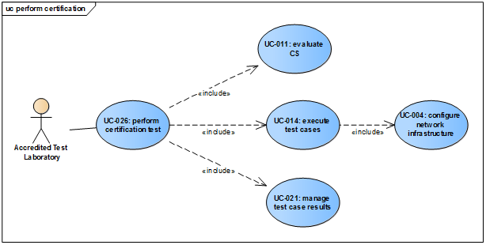
Figure A-3: Use case of Perform Certification Test

Title | Description
UC-004 Configure Network Infrastructure | In the case of a LAN, the network addresses have to be configured and the ports have to be opened. In case of a WAN, further routing and forwarding may have to be configured. This task requires knowledge of networking by both the ATL and the customer.
UC-011 Evaluate CS | The ATL will evaluate the CS pertaining to the SuT and select the relevant ETCs required.
UC-014 Execute Test Cases | The selected test cases are run against the SuT and the results of the test are recorded.
UC-021 Manage Test Case Results | The results of the execution of the ETCs are saved in a secure manner, sent to the CE and the customer. The results are log files for the test execution and a summary with the ETC verdicts.
Table A-11: Use cases related to Perform Certification Test

Definition of Certification work flow
Figure A-4: Use case of Definition Certification Workflow

Title | Description
UC-009 Definition of Certification Workflows | The CE will define the procedures all participants in the certification workflow. The workflow must include the practical needs of a certification test as well as the security needs related to report management and confidentiality of customer data. The customer must be informed of his role when contacting the CE. All other roles must be defined and known for a test laboratory to be accredited.
UC-017 Maintain Certification Process | The AA updates and maintains documented certification process including the CE and ATL operational requirements and criteria for accreditation.
UC-045 Test System Issue Handling | An issue handling system is an important part of any test system, since when a change is made it may invalidate previous results. All issues and any changes or rejections of these issues must be recorded so that the status of the test system and test case interpretations at any point in time is known. The quality of the test system is improved when issues are properly resolved.
UC-046 Certification Workflow Compliance Review | The AA evaluates the conformance of CEs and ATLs with the certification process and operational requirements on a regular basis. The AA provides the CEs with updated ATL status and contact information.
Table A-12: Use cases related to Definition Certification Workflow

Development and Maintenance
The following diagram shows the various developer roles involved in implementing the test tool software. This includes the implementation of the test tool, test cases, and the management system, as well as the maintenance and documentation.
Figure A-5: Use case of Development

Title | Description
UC-020 Maintenance | The test tool requires maintenance to address issues with the tool, test cases, operating system changes, and enhancements, as well as changes in the pattern specifications or interpretation of the pattern specifications.
UC-022 Management System Implementation | The management system will manage the documents and data files related to certification tests. These files will be stored in an online database such as NATO Simulation Resources Library (NSRL). This System must guarantee that the files are transferred and stored in a secure manner to prevent tampering with the contents. The files will be accessed via web services.
UC-030 Provide Documentation | A Developer must provide documentation for the development, maintenance, and enhancement of the test tool. Since even a minor change can cause incompatibilities, it is necessary to know the tool behaviour in each version.
UC-038 Test Case Implementation | The CE is responsible for defining the test case purposes. The abstract test cases (specifying the test steps and allowable reactions) are created by the CE, based on the test purposes. The validation of the abstract test cases against the test purposes is also done by the CE. Test purposes are specified by implementation pattern protocol experts and these are implemented by test case developers as executable test cases. Executable test cases are expected to use a test case library to handle bundled events or other support functions. To prove the valid implementation of the test cases, the log files can be examined and checked against the test purposes. The test case developer implements the executable test cases based on the abstract test cases. The executable test cases are scripts or compiled programs which can be run by the IVCT. The work done by the test case developer also includes the verification of the executable test cases against the abstract test cases and the long-term maintenance of the test cases.
UC-039 Tool Development | Test tool development will take place after working out the design specification. Several test tool developers may work on various independent modules. When the test tool has reached a significant level of maturity and has been employed in certification testing and accepted by the CE, it will be considered to be in the maintenance phase.
Table A-13: Use cases related to Development

Test Tool Development
The test tool development will take place after working out the design specification. Several test tool developers may work on various well-designed Independent modules. When the test tool has reached a significant level of quality and maturity, and has been employed in certification testing and been accepted by the CE, it will be considered to be in the maintenance phase.
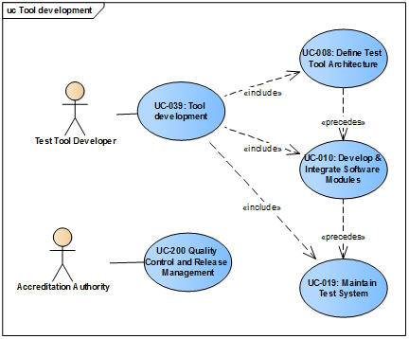
Figure A-6: Use case of Test Tool Development

Title | Description
UC-008 Define Test Tool Architecture | The test tool provides a platform for executing test cases. The test tool can also read in conformance statement files, select test cases, and provides a logging mechanism to generate test case log and summary report files. The basic architecture can be sketched roughly in advance, but exact details of the interfaces have to be agreed upon with the test case developer.
UC-010 Develop & Integrate Software Modules | According to the test tool architecture, define the functionality and interfaces of all modules for the test tool. The individual modules can be given to different developers for implementation. For each module a test concept should be defined to test the module before attempting integration (unit testing). In Java, JUnit is ideal for this purpose and should be used after every change to detect side effects of those changes. JUnit can also be used to help integrate modules and the Junit tests should be defined well in advance. The final integration of all modules should be done at one location with a predefined checklist of functionalities to be tested - a federate should be available to exercise the test cases or integrations tests.
UC-019 Maintain Test System | Whenever the test tool is used an issue may occur that requires a modification or extension to the system. A change to any test cases may invalidate test results and should be handled very carefully. Each issue should be well documented and the software should be checked in to a source control system after each modification.  The CE must review the changes before authorizing a new test tool release.
Table A-14: Use cases related to Test Tool Development

Test Case Implementation
The certification entity is responsible for defining the test case purposes. The abstract test cases (specifying the test steps and allowable reactions) are created by the CE, based on the test purposes. The validation of the abstract test cases against the test purposes is also done by the CE. Test purposes are specified by implementation pattern protocol experts and these are implemented by test case developers into executable test cases. Executable test cases will use a test case library to handle bundled events or other support functions. To prove the valid implementation of the test cases, the log files can be examined and checked against the test purposes. The test case developer implements the executable test cases from the abstract test cases. The executable test cases are scripts or compiled programs which can be started by the IVCT. The work done by the test case developer also includes the verification of the executable test cases against the abstract test cases, and the maintenance of the test cases.
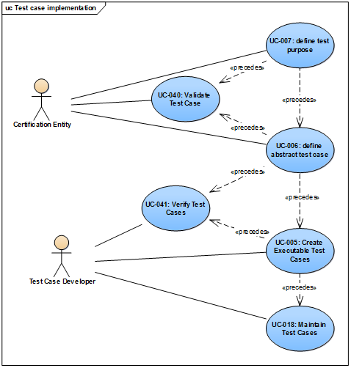
Figure A-7: Use case of Test Case Implementation

Title | Description
UC-005 Create Executable Test Cases | Once the abstract test cases have been validated, a test case developer can start with the implementation of the executable test cases and the supporting library functions in a specific programming language.
UC-006 Define Abstract Test Case | Once the test purposes have been defined, it is possible to define the test steps required to achieve these purposes in the form of abstract test cases. The abstract test cases are the sequences of requests and expected responses independent of a programming language.
UC-007 Define Test Purpose | When a pattern protocol is defined, it is a good idea to define test purposes which will constitute a comprehensive test of the functionality and variations of this functionality. The test purposes should also cover error handling and reactions to invalid behaviour.
UC-018 Maintain Test Cases | During the course of testing the implemented executable test cases, various issues may occur that require changes to them. This maintenance activity should be done in a disciplined manner, since even small changes could invalidate previous certificates. After a change to any executable test case, it should be run against SuTs from two different owners to test for side effects. All changes must be documented in respect to an issue and its solution.
UC-040 Validate Test Case | Once abstract test cases are created, they should be checked to ensure are a valid interpretation of the test purposes. The CE should make sure this is completed before executable test cases are created.
UC-041 Verify Test Cases | Once executable test cases are created, they should be checked to ensure they are a valid interpretation of the abstract test cases. The test case developer should make sure this is completed before they are used for certification testing.
Table A-15: Use cases related to Test Case Implementation

CAPABILITY BADGES, INTEROPERABILITY REQUIREMENTS AND ABSTRACT TEST CASES

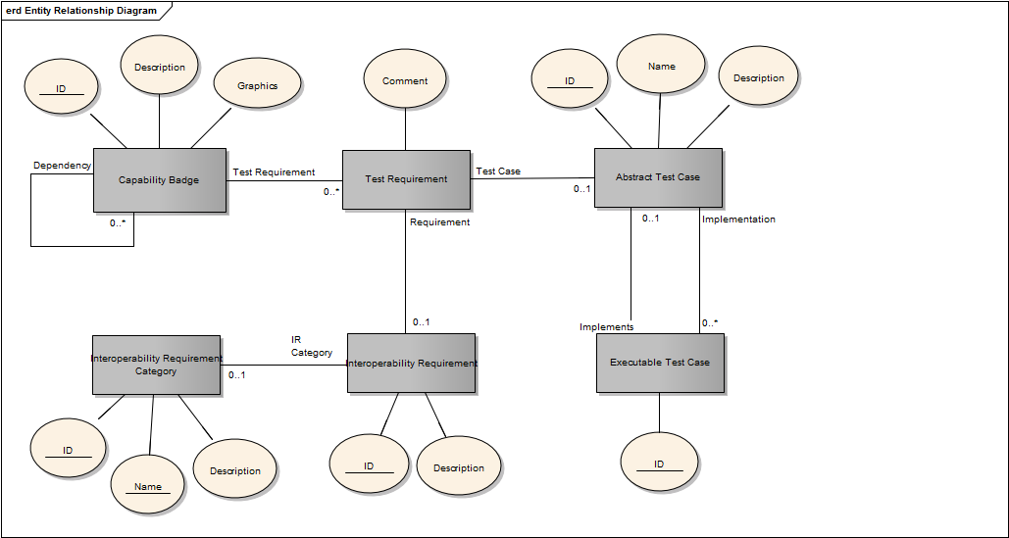
Figure B-1: Key elements of the certification process

INTEROPERABILITY CAPABILITY BADGES
An interoperability Capability Badge (CB) is defined as a token of achievement in terms of passing testing related to Interoperability Requirements (IR) associated with the CB. Successful compliance testing, verification, and certification of individual systems’ compliance with sets of IRs can be labelled using a CB representing this achievement.
The concept of using badges to indicate achievements is nothing new. It can be found in many domains from the scouts to the military. In on-line gaming, badges are frequently used to display an individual gamer's skill, accomplishments, and level of play. The semantics associated with badges and how they are used vary between different domains, and even within a single domain you can find different types of badges showing skill, quantitative and qualitative achievements, accomplishment of a specific mission, and badges showing general maturity or level. Applying the badges concept to interoperability capabilities has been explored in research activities in the UK [CapBadge12] and [CapBadge15].
Achievement graphs are used to specify dependencies between different CBs and to visualise road-maps for increased simulation component interoperability. An achievement graph is used to express implicit requirements for achieving a specific CB that includes requirements related to other badges. E.g. Achieving RPR-ENTITY-2016 also requires achieving the HLA-BASE-2016 CB requirements. By using achievement graphs, combinations/aggregations of CB associated IRs can be expressed.
Figure B-2: Relationships between a CB its associated IRs and the System-under-Test (SuT)

MSG-134 recommends the use of CBs as tokens for passing testing related to interoperability, and as the basis for certificates of compliance. CBs are also used in the Conformance Statements (CS) provided by the SuT owners as the basis for certification.
A CB is identified by name, type and year. It has a short description and a graphical representation ("the badge"). The CB is defined by the set of associated IRs including references to Abstract Test Cases (ATC) describing how the IRs are verified.
The definition of CBs used in the NATO Simulation Interoperability Test and Certification Service is the responsibility of the Accreditation Authority (AA).
An initial set of CBs based on NATO Simulation Interoperability Test and Certification Service priorities have been defined.
ID | Dependency | Description | Graphics
CWIX-DR-2017 | CWIX-ENTITY-2017 | Simulation Interoperability Compliance Badge for CWIX 2017 | 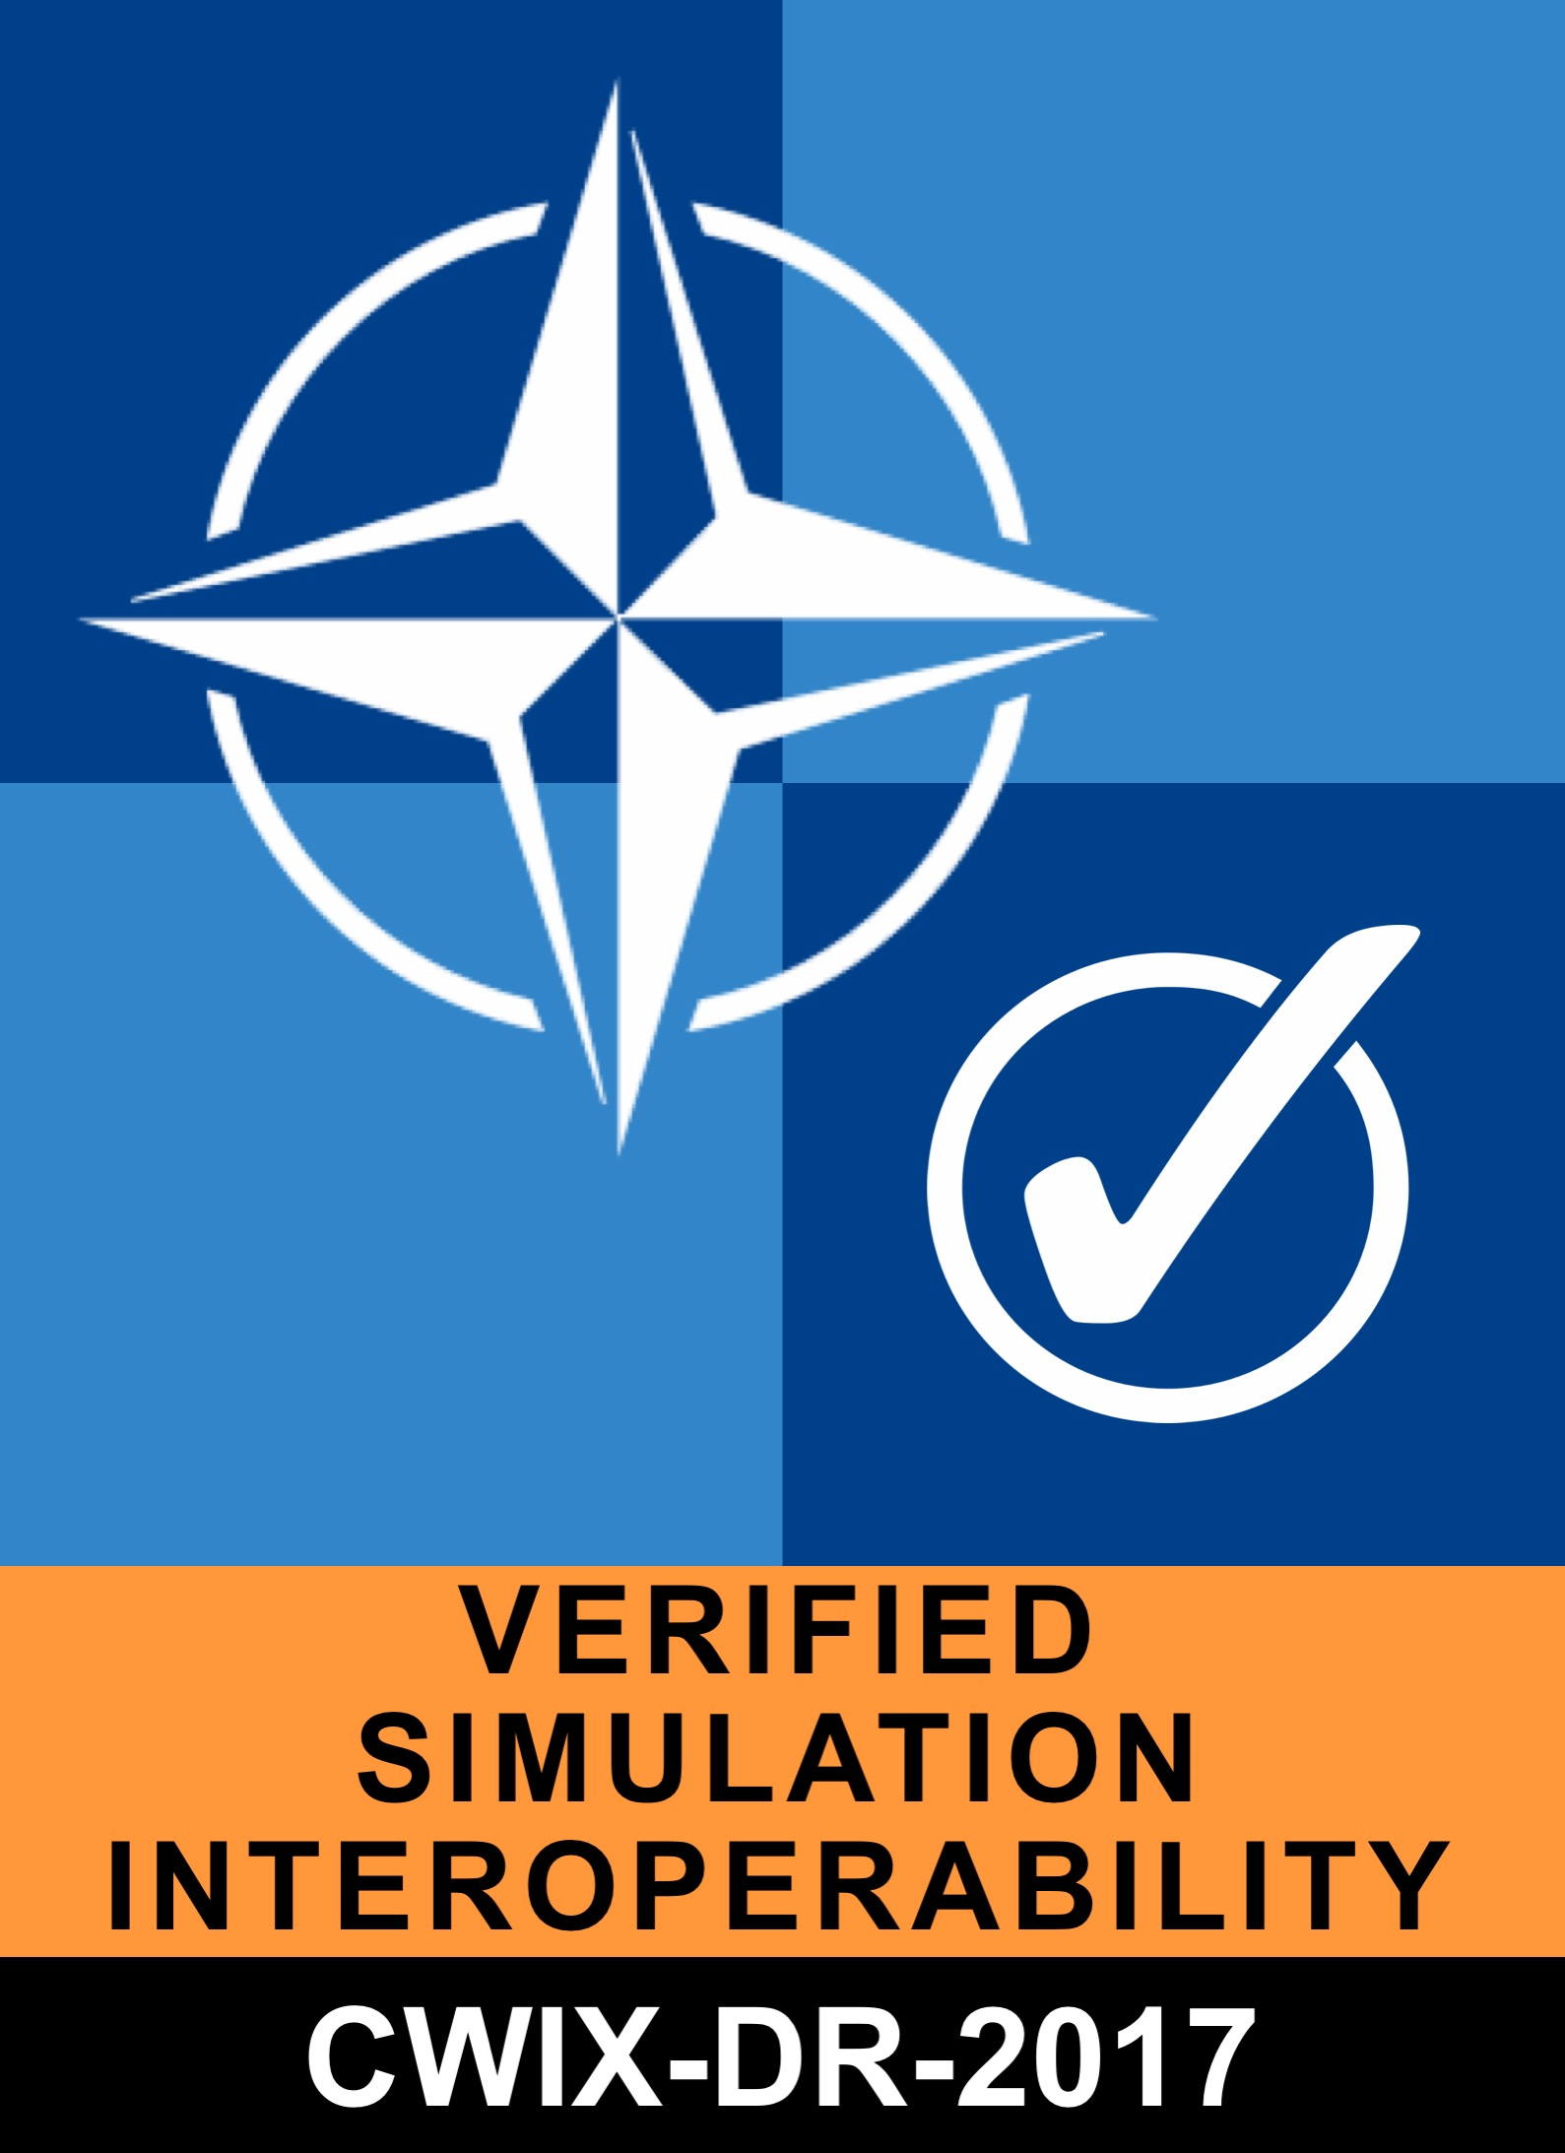
CWIX-ENTITY-2017 |  | Simulation interoperability compliance badge for CWIX 2017 | 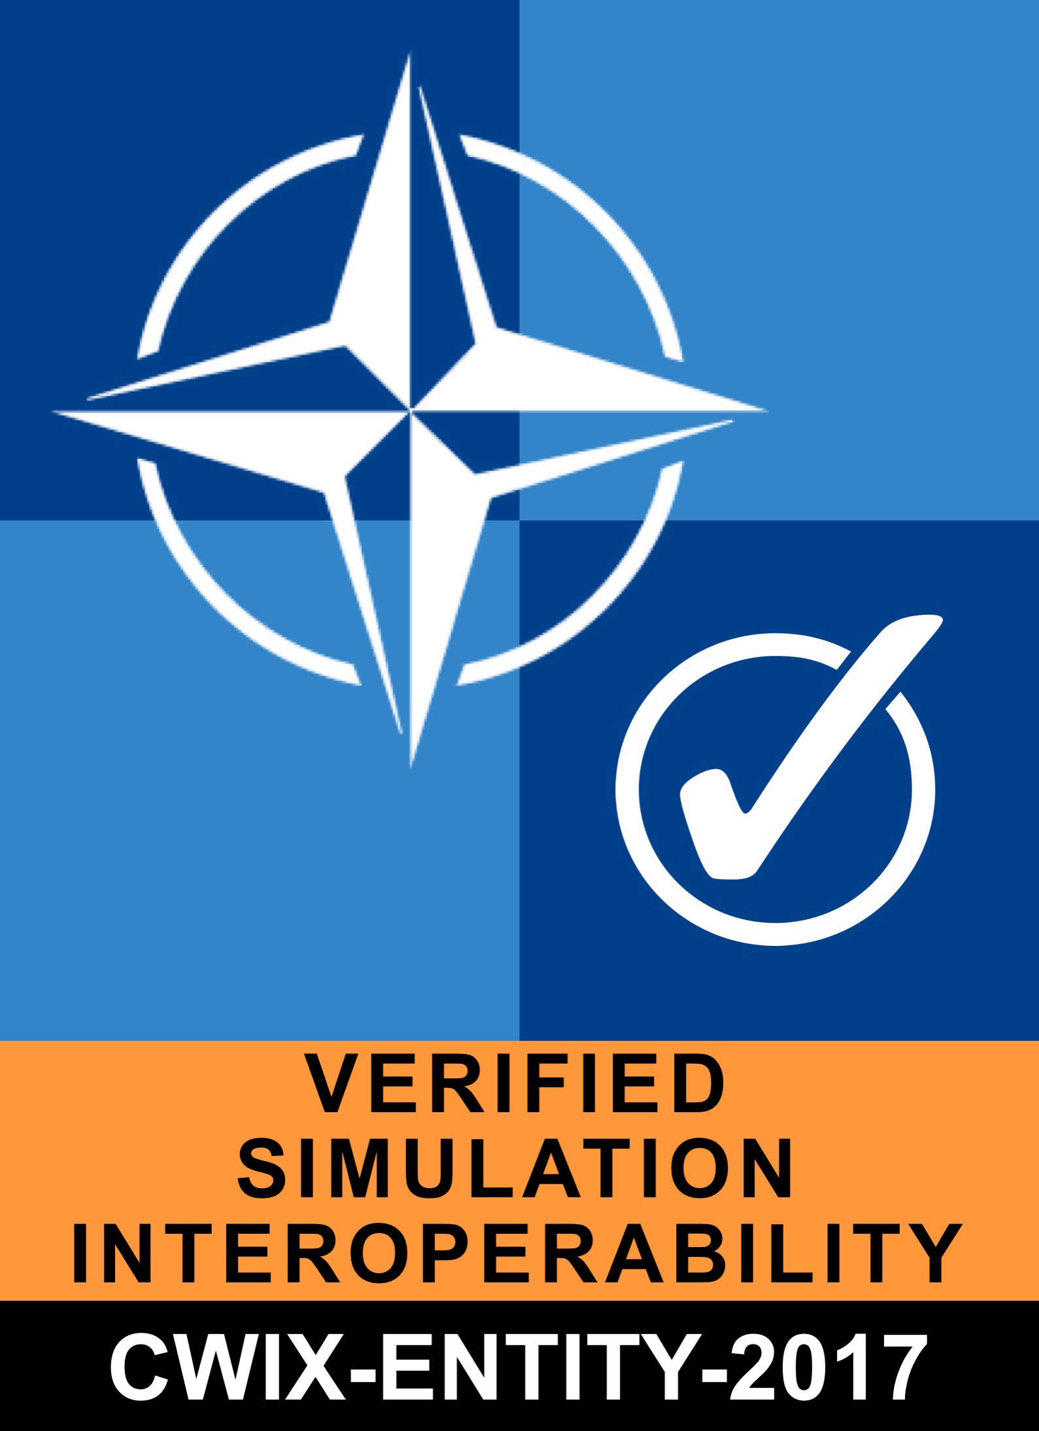
CWIX-WARFARE-2017 | CWIX-ENTITY-2017 | Simulation interoperability compliance badge for CWIX 2017 | 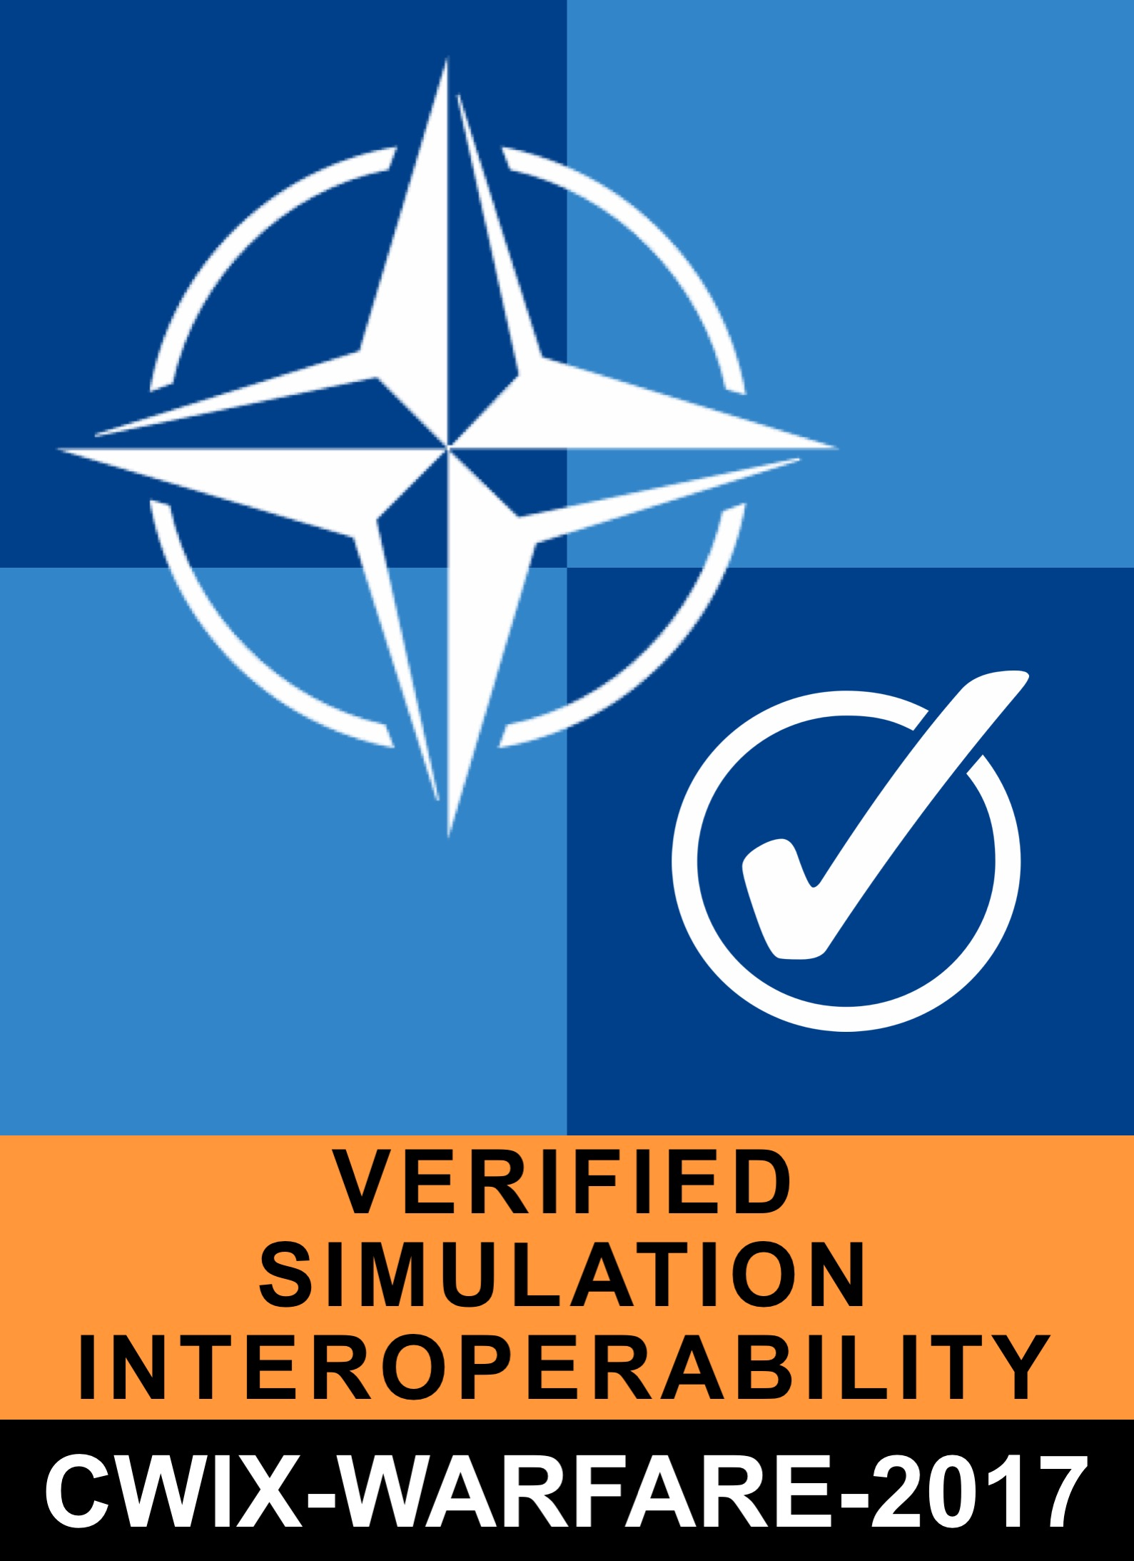
HLA-BASE-2017 |  | Basic CS/SOM and best practices compliance | 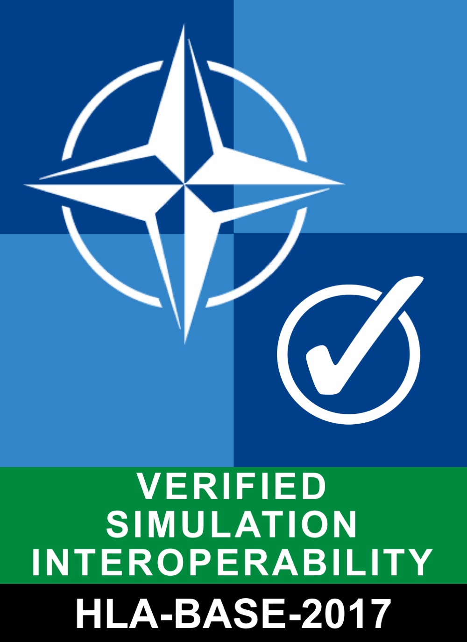
NETN-AGG-2017 | RPR-AGG-2017 | NETN-FOM v2.0 aggregate FOM module | 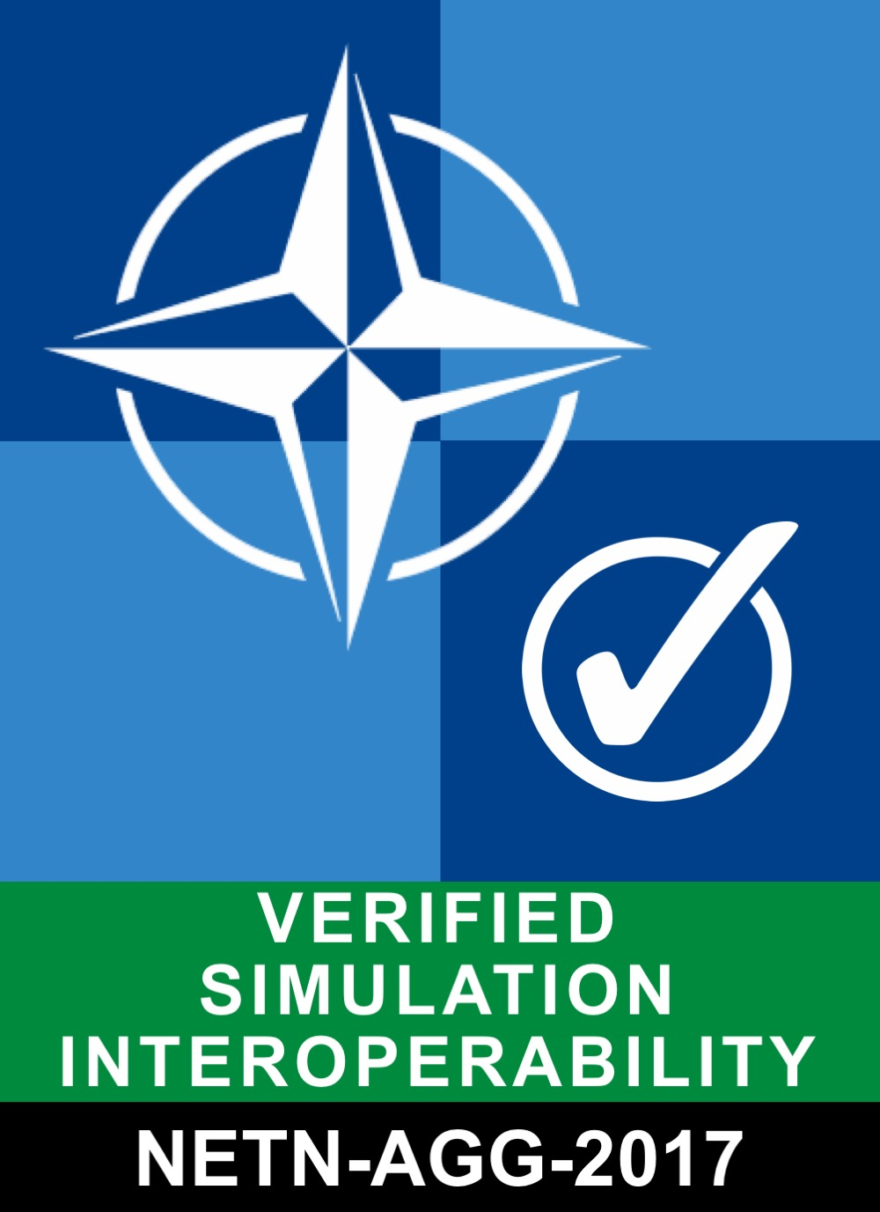
NETN-ENTITY-2017 | RPR-ENTITY-2017 | NETN FOM v2.0 physical FOM module | 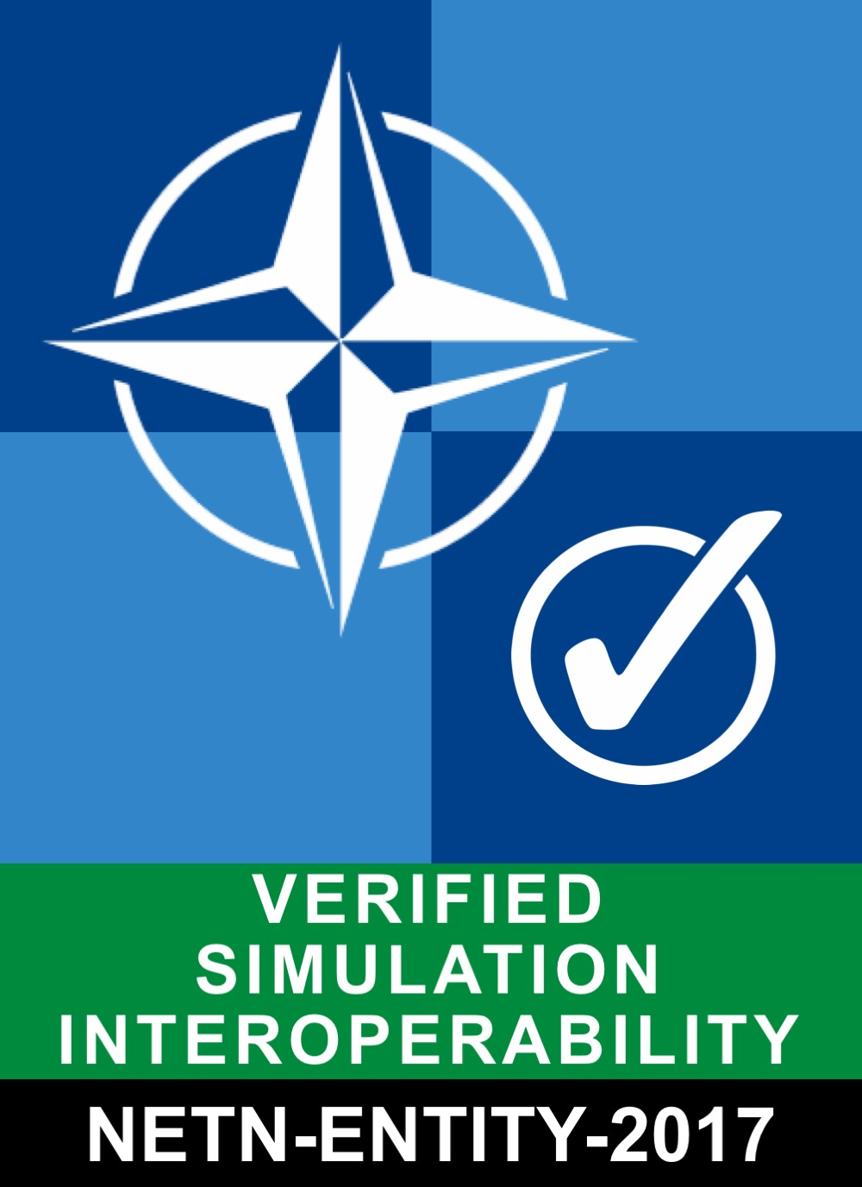
NETN-LBML-INTREP-2017 | NETN-AGG-2017, NETN-ENTITY-2017 | NETN-FOM v2.0 LBML FOM module | 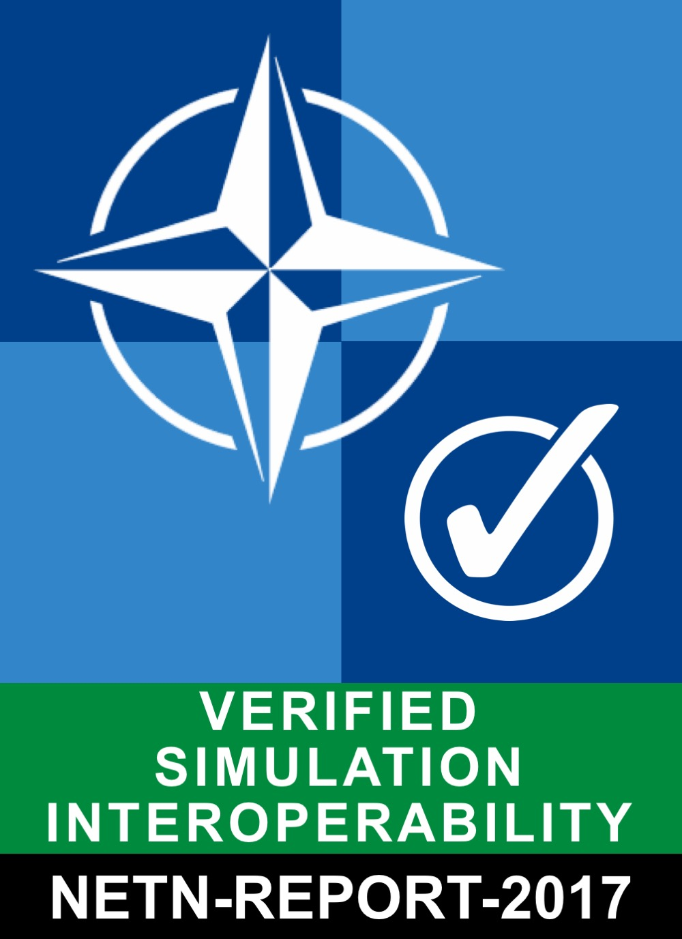
NETN-LBML-OWNSITREP-2017 | NETN-AGG-2017, NETN-ENTITY-2017 | NETN-FOM v2.0 LBML FOM module
NETN-LBML-TASK-2017 | NETN-AGG-2017, NETN-ENTITY-2017 | NETN-FOM v2.0 LBML FOM module | 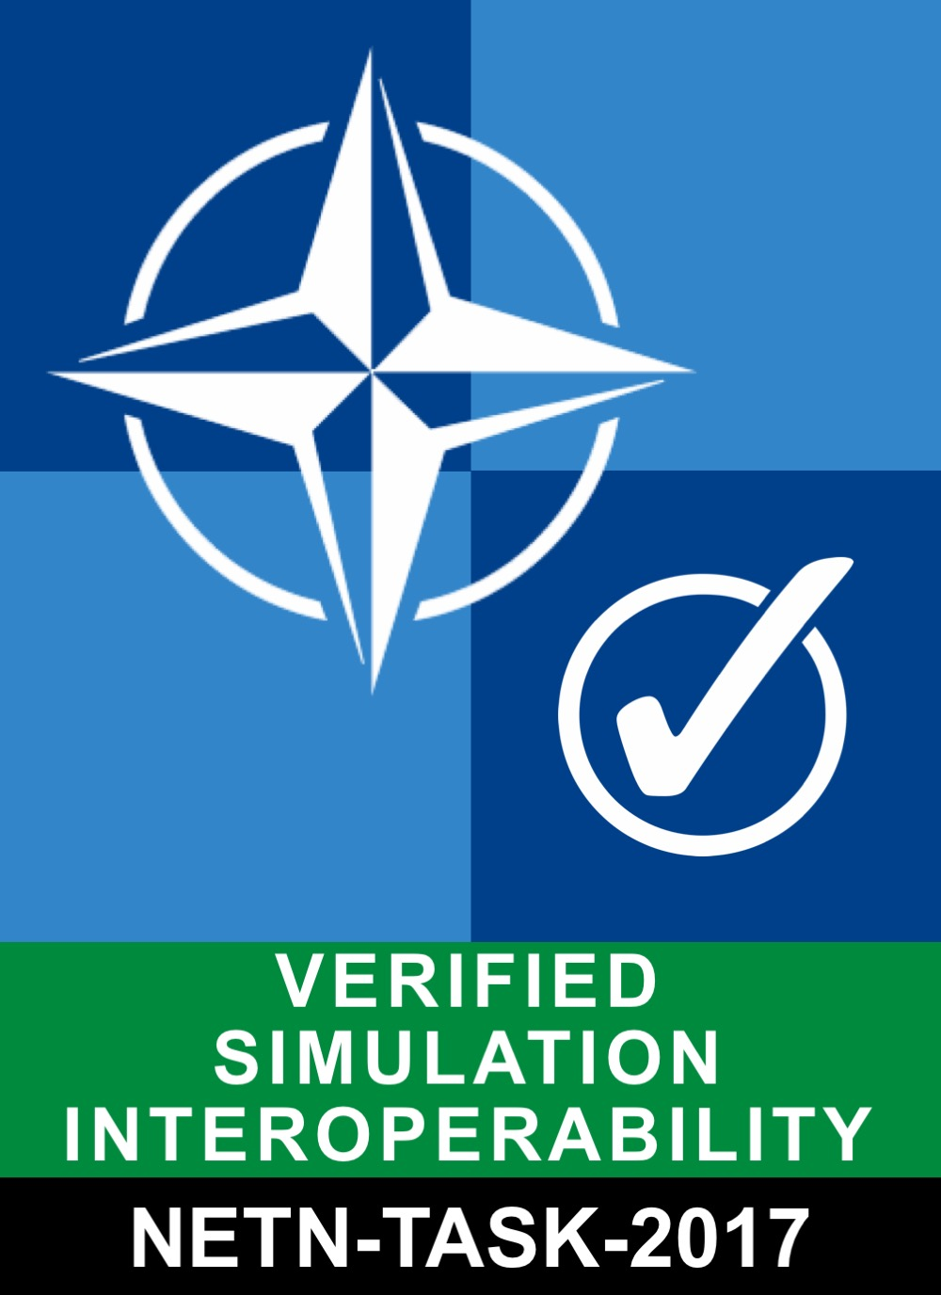
NETN-MRM-2017 | NETN-TMR-2017 | NETN FOM v2.0 MRM FOM module | 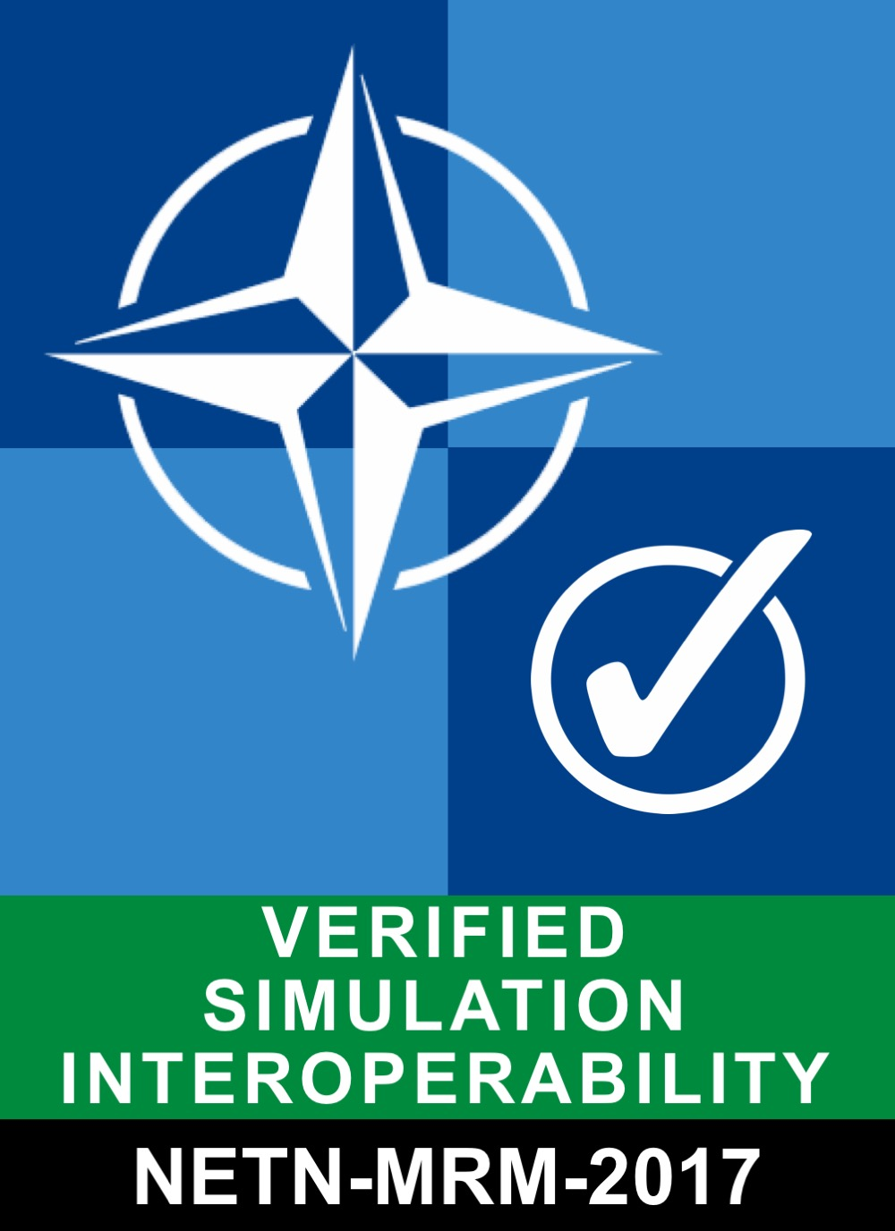
NETN-TMR-2017 | HLA-BASE-2017 | Basic support for NETN TMR pattern (AMSP-04 Ed A). SuT is able to respond to TMR requests. | 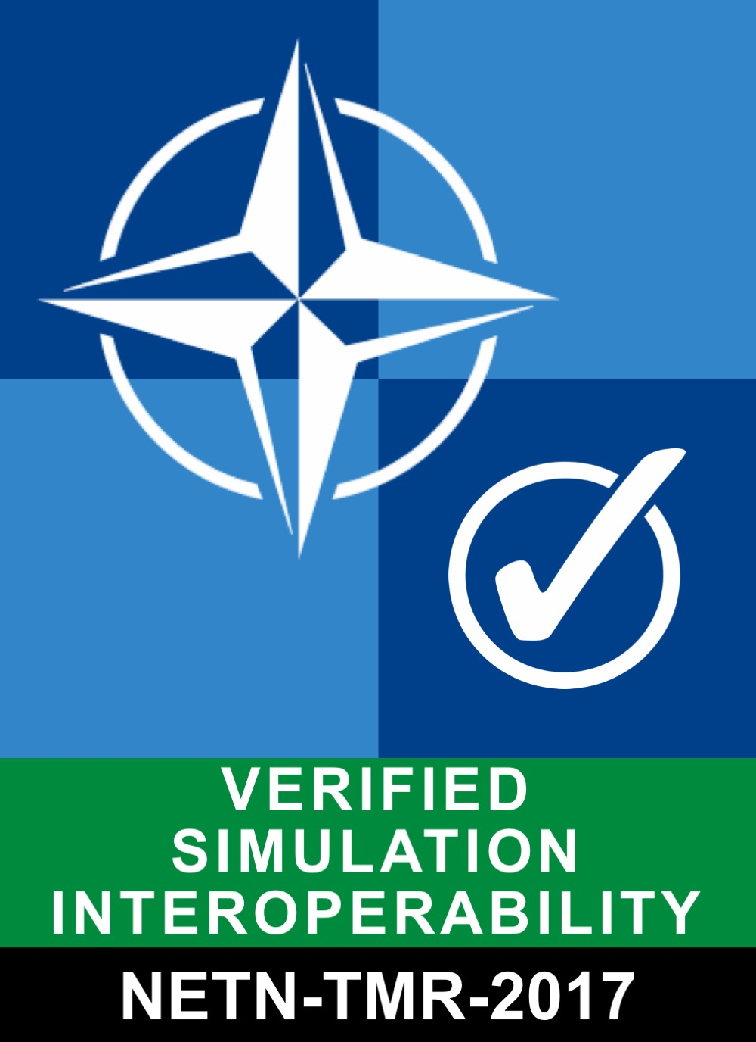
RPR-AGG-2017 | HLA-BASE-2017 | RPR-FOM v2.0 aggregate FOM Module | 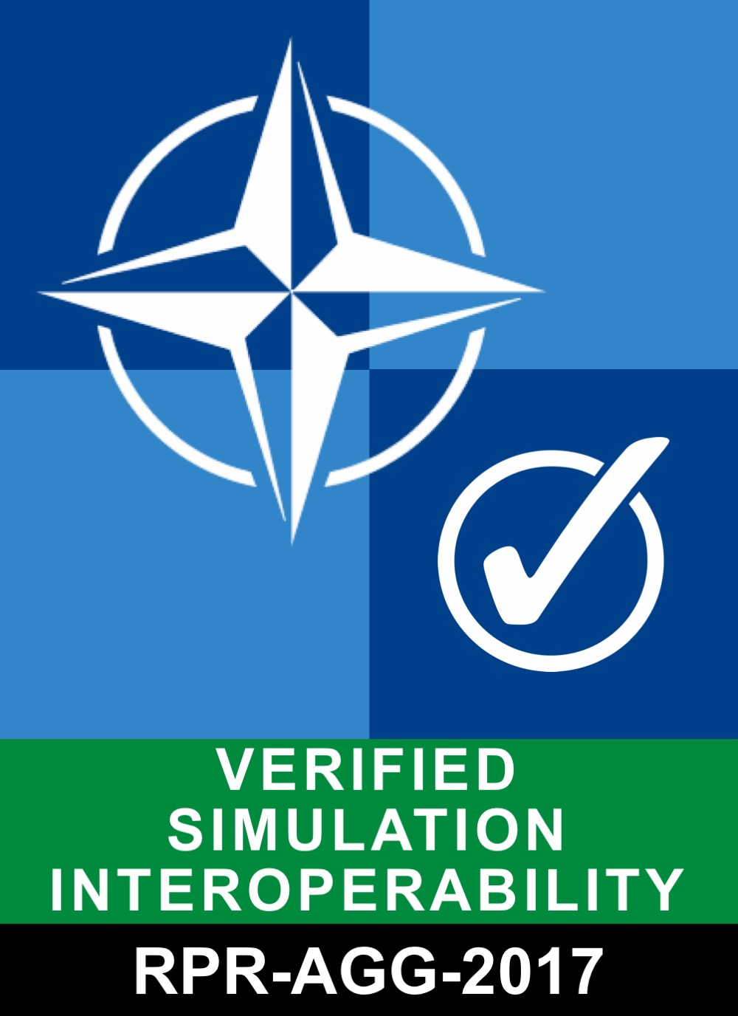
RPR-ENTITY-2017 | HLA-BASE-2017 | RPR-FOM v2.0 physical FOM Module support. GRIM compliance wrt. Platforms, Lifeforms etc. representation of required attributes. | 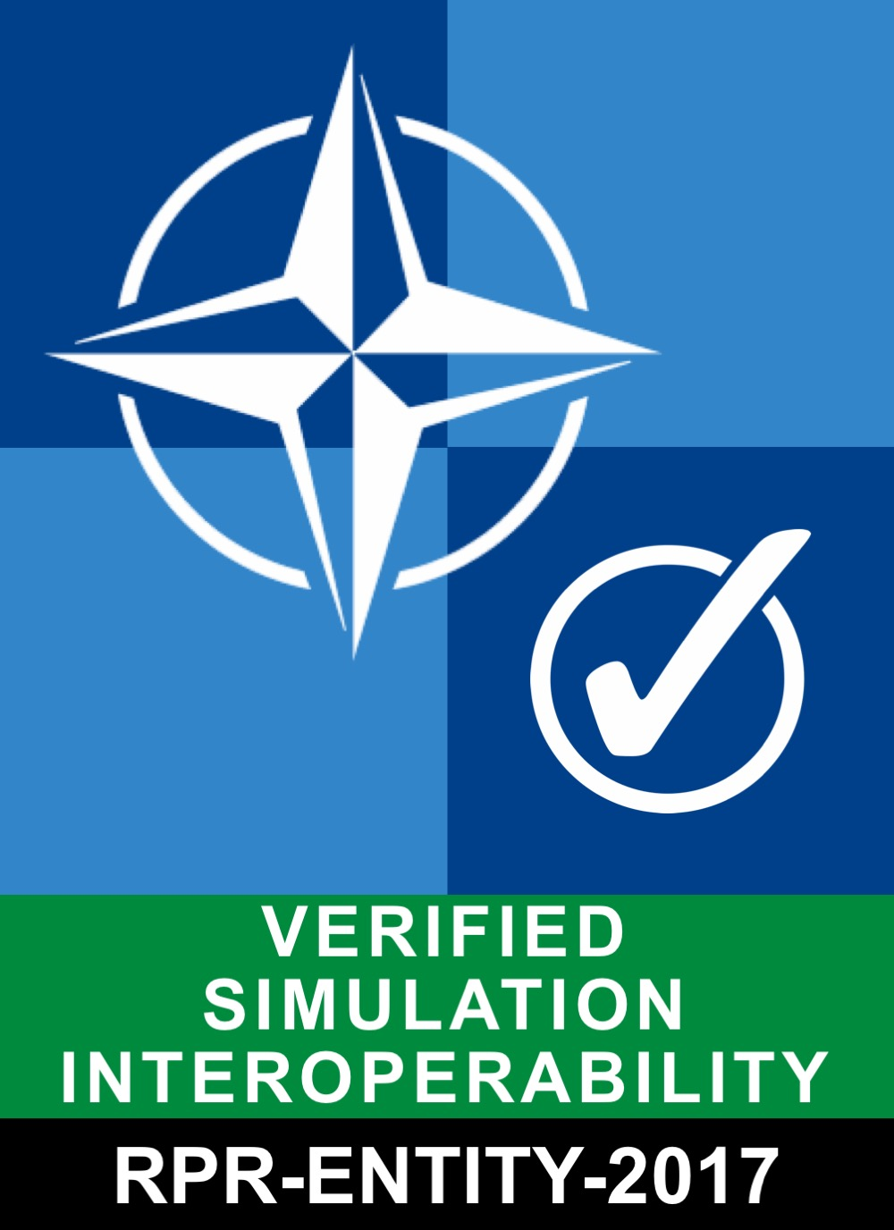
RPR-WARFARE-2017 | HLA-BASE-2017 RPR-ENTITY-2017 | RPR-Warfare v2.0 FOM module support. | 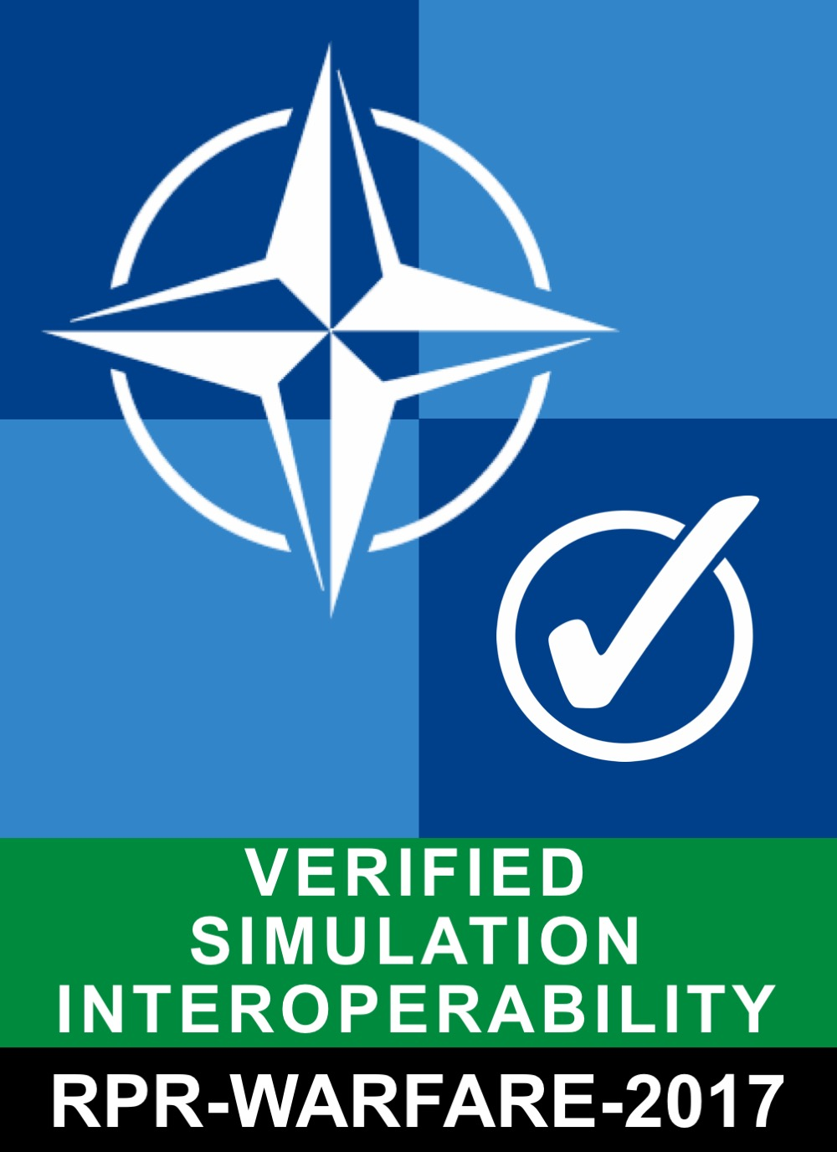
Table B-1: Interoperability Capability Badges

INTEROPERABILITY REQUIREMENTS
A simulation Interoperability Requirement (IR) is related to how distributed systems interact and exchange information in order to collectively meet overall simulation objectives. IRs are specified to ensure that a system component can be easily combined and interoperate with other system components. The ability of a system to interoperate can be described as the set of fulfilled IR requirements.
Sets of related IRs can be defined and grouped to form interoperability Capability Badges (CB) used to express a systems capability to interoperate on a higher level than individual IRs.
IRs can also be grouped and associated with Abstract Test Cases (ATCs) as the implicit purpose of ATCs is to verify all associated IRs. IRs can be grouped into categories.
ID | Name | Description
BP | Best Practice Conformance | Requirements related to best practices for distributed simulation
DOC | Documentation Conformance | Requirements for documenting interoperability capabilities
NETN | NETN Requirements | Requirements related to NETN FAFD, AMSP-04 Ed A, STANREC 4800
RPR2 | RPR2 Requirements | Requirements related to RPR-FOM v2.0
SOM | Simulation Object Model Conformance | Requirements related to the conformance of a SuT to the SOM provided in a CS
Table B-2: Categories of Interoperability Requirement

Initial set of Interoperability Requirements as identified by MSG-134
ID | Category | Description
IR-BP-0001 | BP | The SuT shall provide attribute value updates for requested attributes owned by the SuT
IR-BP-0002 | BP | The SuT shall create a federation execution before joining, if it does not already exist
IR-BP-0003 | BP | The SuT shall create or join a federation execution with only those FOM modules that are specified in its CS
IR-BP-0004 | BP | The SuT shall be configurable for the following parameters: FederateType, FederateName, FederationName
IR-BP-0005 | SOM | The SuT shall remove at least one object instance if RemoveObjectInstance HLA service is described as used in CS/SOM
IR-BP-0006 | SOM | The SuT shall resign federation if ResignFederation HLA service is described as used in CS/SOM
IR-BP-0007 | SOM | The SuT shall only update values, for attributes with the Enumerated Datatype, compliant with the Distributed  Simulation Agreement
IR-DOC-0001 | DOC | The SuT interoperability capabilities shall be documented in a conformance statement including a SOM and a FOM with a minimum set of supporting FOM modules
IR-NETN-0001 | NETN | The SuT shall comply with STANREC 4800, AMSP-04 NETN FAFD Ed A, October 2017
IR-NETN-0002 | NETN | The SuT shall define BaseEntity.AggregateEntity.NETN_Aggregate as published and/or subscribed in its CS/SOM
IR-NETN-0003 | NETN | The SuT shall update the following required attributes for NETN_Aggregate object instances registered by SuT: UniqueID, Callsign, Status, Echelon, HigherHeadquarters, AggregateState, Dimensions, EntityIdentifier, EntityType, Spatial.
IR-NETN-0004 | NETN | The SuT updates of NETN_Aggregate instance attributes shall be valid according to STANREC 4800.
IR-NETN-0005 | NETN | The SuT shall assume default values for optional attributes on instances of NETN_Aggregate object class.
IR-NETN-0006 | NETN | The SuT shall not rely on updates of optional attributes on instances of NETN_Aggregate object class.
IR-NETN-0007 | NETN | The SuT shall use pre-defined IDs to generate the same UniqueID for an NETN_Aggregate instance in different Federation Executions.
IR-NETN-0008 | NETN | The SuT shall document in its CS if it acts as a NETN TMR trigger, requesting and/or responding federate
IR-NETN-0009 | NETN | The SuT triggering TMR shall define TMR_InitiateTransferModellingResponsibility as published in its CS/SOM.
IR-NETN-0010 | NETN | The SuT triggering TMR shall define TMR_OfferTransferModellingResponsibility as subscribed in its CS/SOM.
IR-NETN-0011 | NETN | The SuT triggering TMR shall define TMR_TransferResult as subscribed in its CS/SOM.
IR-NETN-0012 | NETN | The SuT requesting TMR shall define TMR_InitiateTransferModellingResponsibility as subscribed in its CS/SOM.
IR-NETN-0013 | NETN | The SuT requesting TMR shall define TMR_OfferTransferModellingResponsibility as published and subscribed in its CS/SOM.
IR-NETN-0014 | NETN | The SuT requesting TMR shall define TMR_TransferResult as published in its CS/SOM.
IR-NETN-0015 | NETN | The SuT requesting TMR shall define TMR_RequestTransferModellingResponsibility as published in the CS/SOM.
IR-NETN-0016 | NETN | The SuT requesting TMR shall define TMR_CancelRequest as published in CS/SOM.
IR-NETN-0017 | NETN | The SuT responding to TMR shall define TMR_RequestTransferModellingResponsibility as subscribed in the CS/SOM.
IR-NETN-0018 | NETN | The SuT responding to TMR shall define TMR_OfferTransferModellingResponsibility as published in the CS/SOM.
IR-NETN-0019 | NETN | The SuT responding to TMR shall define TMR_CancelRequest as subscribed in CS/SOM.
IR-NETN-0020 | NETN | The SuT triggering TMR shall comply with TMR design pattern for a TMR Triggering federate as documented in NETN FAFD, STANREC 4800.
IR-NETN-0021 | NETN | The SuT requesting TMR shall comply with TMR design pattern for a TMR Requesting federate as documented in NETN FAFD, STANREC 4800.
IR-NETN-0022 | NETN | The SuT responding to TMR shall comply with TMR design pattern for TMR Responding federate as documented in NETN FAFD, STANREC 4800.
IR-NETN-0023 | NETN | The SuT shall respond to a TMR_InitiateTransferModellingResponsibility directed to the SuT with a negative TMR_OfferTransferModellingResponsibility if it is not possible to initiate a transfer of modelling responsibility.
IR-NETN-0024 | NETN | The SuT shall respond to a TMR_InitiateTransferModellingResponsibility directed to the SuT with a positive TMR_OfferTransferModellingResponsibility if it is possible to initiate a transfer of modelling responsibility.
IR-NETN-0025 | NETN | The SuT shall respond to a TMR_InitiateTransferModellingResponsibility directed to the SuT with a TMR_TransferResult.
IR-NETN-0026 | NETN | The SuT shall not respond to a TMR_InitiateTransferModellingResponsibility if it is not directed to the SuT.
IR-NETN-0027 | NETN | The SuT shall respond to a TMR_RequestTransferModellingResponsibility directed to the SuT with a negative TMR_OfferTransferModellingResponsibility if it is not possible to perform a transfer of modelling responsibility.
IR-NETN-0028 | NETN | The SuT shall respond to a TMR_RequestTransferModellingResponsibility directed to the SuT with a positive TMR_OfferTransferModellingResponsibility if it is possible to perform a transfer of modelling responsibility.
IR-NETN-0029 | NETN | The SuT shall not respond to a TMR_RequestTransferModellingResponsibility if it is not directed to the SuT.
IR-NETN-0030 | NETN | The SuT shall, if SuT responds positive to a TMR_RequestTransferModellingResponsibility, use HLA services to perform TMR according to pattern defined in NETN FAFD, STANREC 4800.
IR-NETN-0031 | NETN | The SuT shall cancel or not perform TMR as a response to a TMR_CancelRequest directed to the SuT.
IR-NETN-0032 | NETN | The SuT shall document time-out condition for receiving a TMR_OfferTransferModellingResponsibility corresponding to a TMR_RequestTransferModellingResponsibility sent by the SuT.
IR-NETN-0033 | NETN | The SuT shall send TMR_CancelRequest after TMR_RequestTransferModellingResponsibility sent by SuT has timed-out.
IR-NETN-0034 | NETN | The SuT acting as a MRM Service Provider shall define interaction class MRM_AggregationRequest as published in its CS/SOM.
IR-NETN-0035 | NETN | The SuT acting as a MRM Service Provider shall define interaction class MRM_AggregationResponse as subscribed in its CS/SOM.
IR-NETN-0036 | NETN | The SuT acting as a MRM Service Provider shall define interaction class MRM_ActionComplete as published in its CS/SOM.
IR-NETN-0037 | NETN | The SuT MRM Service Provider shall respond to interaction MRM_Trigger with interaction MRM_TriggerResponse.
IR-NETN-0038 | NETN | The SuT MRM Service Provider shall send interaction MRM_ActionComplete, positive result when MRM actions are completed.
IR-NETN-0040 | NETN | The SuT MRM Aggregate Federate shall comply with MRM design pattern for a MRM Service Provider federate as documented in NETN FAFD, STANREC 4800.
IR-NETN-0041 | NETN | The SuT acting as a Aggregate Federate shall define object class NETN_Aggregate as published and subscribed in its CS/SOM.
IR-NETN-0042 | NETN | The SuT acting as a Aggregate Federate shall define interaction class MRM_DisaggregationRequest as subscribed in its CS/SOM.
IR-NETN-0043 | NETN | The SuT acting as a Aggregate Federate shall define interaction class MRM_DisaggregationResponse as published in its CS/SOM.
IR-NETN-0044 | NETN | The SuT acting as a Aggregate Federate shall define interaction class MRM_AggregationRequest as subscribed in its CS/SOM.
IR-NETN-0045 | NETN | The SuT acting as a Aggregate Federate shall define interaction class MRM_AggregationResponse as published in its CS/SOM.
IR-NETN-0046 | NETN | The SuT acting as a Aggregate Federate shall define interaction class MRM_ActionComplete as subscribed in its CS/SOM.
IR-NETN-0047 | NETN | The SuT Aggregate Federate shall respond to interaction MRM_DisaggregationRequest with interaction MRM_DisaggregationResponse.
IR-NETN-0048 | NETN | The SuT Aggregate Federate shall respond to interaction MRM_AggregationRequest with interaction MRM_AggregationResponse.
IR-NETN-0049 | NETN | The SuT MRM Higher Resolution Federate shall comply with MRM design pattern for a MRM Service Provider federate as documented in NETN FAFD, STANREC 4800.
IR-NETN-0050 | NETN | The SuT acting as a Higher Resolution Federate shall define the NETN-Physical leaf object classes as published and subscribed in its CS/SOM.
IR-NETN-0051 | NETN | The SuT acting as a Higher Resolution Federate hall define interaction class MRM_DisaggregationRequest as subscribed in its CS/SOM.
IR-NETN-0052 | NETN | The SuT acting as a Higher Resolution Federate hall define interaction class MRM_DisaggregationResponse as published in its CS/SOM.
IR-NETN-0053 | NETN | The SuT acting as a Higher Resolution Federate hall define interaction class MRM_AggregationRequest as subscribed in its CS/SOM.
IR-NETN-0054 | NETN | The SuT acting as a Higher Resolution Federate hall define interaction class MRM_AggregationResponse as published in its CS/SOM.
IR-NETN-0055 | NETN | The SuT acting as a Higher Resolution Federate shall define interaction class MRM_ActionComplete as subscribed in its CS/SOM.
IR-NETN-0056 | NETN | The SuT Higher Resolution Federate shall respond to interaction MRM_DisaggregationRequest with interaction MRM_DisaggregationResponse.
IR-NETN-0057 | NETN | The SuT Higher Resolution Federate shall respond to interaction MRM_AggregationRequest with interaction MRM_AggregationResponse.
IR-NETN-0058 | NETN | The SuT MRM Service Provider shall, if SuT receives positive MRM_DisaggregationResponse, use HLA services and TMR interactions to perform MRM disaggregation according to pattern defined in NETN FAFD, STANREC 4800.
IR-NETN-0059 | NETN | The SuT MRM Service Provider shall, if SuT receives positive MRM_AggregationResponse, use HLA services and TMR interactions to perform MRM aggregation according to pattern defined in NETN FAFD, STANREC 4800.
IR-NETN-0060 | NETN | The SuT Aggregate or Higher Resolution Federate shall, if SuT responds positive to a MRM_DisaggregationRequest, use HLA services and TMR interactions to perform MRM disaggregation according to pattern defined in NETN FAFD, STANREC 4800.
IR-NETN-0061 | NETN | The SuT Aggregate or Higher Resolution Federate shall, if SuT responds positive to a MRM_AggregationRequest, use HLA services and TMR interactions to perform MRM aggregation according to pattern defined in NETN FAFD, STANREC 4800.
IR-NETN-0062 | NETN | The SuT Aggregate or Higher Resolution Federate shall, if SuT responds positive to a MRM_AggregationRequest, use HLA services and TMR interactions to perform MRM aggregation according to pattern defined in NETN FAFD, STANREC 4800.
IR-NETN-0063 | NETN | The SuT shall define BaseEntity.AggregateEntity.NETN_Aggregate or a subclass and/or a NETN subclass of BaseEntity.PhysicalEntity as published and/or subscribed in CS/SOM.
IR-NETN-0064 | NETN | The SuT defined as producer in CS/SOM shall for LBMLMessage.LBMLTask leaf interactions provide the following required parameters for the LBMLMessage.LBMLTask leaf classes: Task, Taskee, Tasker, TaskType.
IR-NETN-0065 | NETN | The SuT defined as producer in its CS/SOM shall for LBMLMessage.LBMLTask leaf interactions provide all required parameters defined in the LBMLMessage.LBMLTask leaf interaction class.
IR-NETN-0066 | NETN | The SuT shall define NETN LBMLMessage.LBMLTask.MoveToLocation and LBMLMessage.LBMLTask.MoveToUnit as published and/or subscribed in CS/SOM.
IR-NETN-0067 | NETN | The SuT shall define at least one leaf interaction class of NETN LBMLMessage.LBMLTaskManagement (CancelAllTasks, CancelSpecifiedTasks) as published and/or subscribed in its CS/SOM.
IR-NETN-0068 | NETN | The SuT shall define NETN LBMLReport.StatusReport.TaskStatusReport as subscribed in its CS/SOM if SuT has defined leaf classes of LBMLTas as published in CS/SOM
IR-NETN-0069 | NETN | The SuT shall define NETN LBMLReport.StatusReport.TaskStatusReport as published in its CS/SOM if SuT has defined leaf classes of LBMLTas as subscribed in its CS/SOM
IR-NETN-0070 | NETN | The SuT shall define NETN LBMLMessage.LBMLTask.FireAtLocation and LBMLMessage.LBMLTask.FireAtUnit or subclasses of these as published and/or subscribed in its CS/SOM.
IR-NETN-0071 | NETN | The SuT defined as consumer in its CS/SOM shall for NETN LBMLMessage.LBMLTask.FireAtLocation and LBMLMessage.LBMLTask.FireIndirectWM fire at the specified location.
IR-NETN-0072 | NETN | The SuT defined as consumer in its CS/SOM shall for NETN LBMLMessage.LBMLTask.FireAtUnit and LBMLMessage.LBMLTask.FireDirectWM fire at the specified unit.
IR-NETN-0073 | NETN | The SuT defined as a consumer in its CS/SOM shall clear all tasks at the entity when an LBMLMessage.LBMLTaskManagement.CancelAllTasks is received.
IR-NETN-0074 | NETN | The SuT defined as a consumer in its CS/SOM shall clear the tasks at the entity that is specified in the LBMLMessage.LBMLTaskManagement.CancelSpecifiedTasks when it is received.
IR-NETN-0075 | NETN | The SuT defined as consumer in its CS/SOM shall for NETN LBMLMessage.LBMLTask.MoveToLocation and LBMLMessage.LBMLTask.MoveToUnit move the specified unit to the specified location and if the route is specified use it.
IR-NETN-0076 | NETN | The SuT defined as a producer of NETN LBMLReport.StatusReport.TaskStatusReport in its CS/SOM shall respond to a leaf class of LBMLMessage.LBMLTask with a status report of the task (Accepted/Refused).
IR-NETN-0077 | NETN | The SuT defined as a producer of NETN LBMLReport.StatusReport.TaskStatusReport in its CS/SOM shall update the status of the task (Aborted/Completed) when the status change.
IR-NETN-0078 | NETN | The SuT shall define LBMLReport.SpotReport.ActivitySpotReport.CurrentActivitySpotReport as published and/or subscribed in its CS/SOM.
IR-NETN-0079 | NETN | The SuT defined as a provider in its CS/SOM shall define BaseEntity.AggregateEntity.NETN_Aggregate or a subclass and/or a NETN subclass of BaseEntity.PhysicalEntity as subscribed in its CS/SOM.
IR-NETN-0080 | NETN | The SuT defined as a provider in SOM/CS shall send LBMLReport.SpotReport.ActivitySpotReport.CurrentActivitySpotReport about spotted enemies, neutral, or unknown units (in realation to the observer) when these are able to observ (determined by the SuT observing model).
IR-NETN-0081 | NETN | The SuT shall define LBMLReport.StatusReport.ActivityStatusReport.CurrentActivityStatusReport as published and/or subscribed in its CS/SOM.
IR-NETN-0082 | NETN | The SuT defined as a provider in its CS/SOM shall define BaseEntity.AggregateEntity.NETN_Aggregate or a subclass and/or a NETN subclass of BaseEntity.PhysicalEntity as published in its CS/SOM.
IR-NETN-0083 | NETN | The SuT defined as a provider in its SOM/CS shall send LBMLReport.StatusReport.ActivityStatusReport.CurrentActivityStatusReport from friendly units about their own (perceived) state.
IR-NETN-0084 | NETN | The SuT defined as a consumer in its SOM/CS shall receive LBMLReport.StatusReport.ActivityStatusReport.CurrentActivityStatusReport for friendly units about their (perceived) state and base its low level BML tasks on this perceived truth data of blue units instead of RPR ground truth data.
IR-NETN-0085 | NETN | The SuT defined as a consumer in its SOM/CS shall receive LBMLReport.SpotReport.ActivitySpotReport.CurrentActivitySpotReport for spotted enemy, neutral, or unknown unit and base its low level BML tasks on this perceived truth data on non-friendly / unknown units instead of RPR ground truth data.
IR-RPR2-0001 | RPR2 | The SuT shall comply with SISO-STD-001-2015, Standard for Guidance, Rationale, and Interoperability Modalities for the Real-time Platform Reference Federation Object Model, Version 2.0, 10 August 2015
IR-RPR2-0002 | RPR2 | The SuT shall define BaseEntity.AggregateEntity as published or define a subclass of BaseEntity.AggregateEntity as published and/or define BaseEntity.AggregateEntity as subscribed in its CS/SOM.
IR-RPR2-0003 | RPR2 | The SuT shall update the following required attributes for AggregateEntity object instances registered by SuT: AggregateState, Dimensions, EntityIdentifier, EntityType, Spatial.
IR-RPR2-0004 | RPR2 | The SuT updates of AggregateEntity instance attributes shall be valid according to SISO-STD-001-2015 and SISO-STD-001.1-2015.
IR-RPR2-0005 | RPR2 | The SuT shall assume default values for optional attributes on instances of AggregateEntity object class.
IR-RPR2-0006 | RPR2 | The SuT shall not rely on updates of optional attributes on instances of AggregateEntity object class.
IR-RPR2-0007 | RPR2 | The SuT shall be configurable for the following parameters: SiteID, ApplicationID.
IR-RPR2-0008 | RPR2 | The SuT shall define at least one leaf object class of BaseEntity.PhysicalEntity as published and/or subscribed in its CS/SOM.
IR-RPR2-0009 | RPR2 | The SuT shall in CS specify the use of Articulated Parts for all published and subscribedBaseEntity.PhysicalEntity and subclasses.
IR-RPR2-0010 | RPR2 | The SuT shall, in its, CS specify the use of Dead-Reckoning algorithms for all published and subscribed BaseEntity.PhysicalEntity and subclasses.
IR-RPR2-0011 | RPR2 | The SuT shall update the following required attributes for PhysicalEntity subclass object instances registered by SuT: EntityIdentifier, EntityType, Spatial.
IR-RPR2-0012 | RPR2 | The SuT shall not update non-applicable PhysicalEntity Attributes as specified in Domain Appropriateness table in SISO-STD-001-2015.
IR-RPR2-0013 | RPR2 | The SuT updates of instance attributes shall, for BaseEntity.PhysicalEntity and subclasses, be valid according to SISO-STD-001-2015 and SISO-STD-001.1-2015.
IR-RPR2-0014 | RPR2 | The SuT updates of instance attribute Spatial shall, for BaseEntity.PhysicalEntity and subclasses, include valid Dead-Reckoning parameters for supported algorithms as specified in its CS.
IR-RPR2-0015 | RPR2 | The SuT shall assume default values for optional attributes on instances of BaseEntity.PhysicalEntity and subclasses according to SISO-STD-001-2015.
IR-RPR2-0016 | RPR2 | The SuT shall not rely on updates of optional attributes on instances of BaseEntity.PhysicalEntity and subclasses.
IR-RPR2-0017 | RPR2 | The SuT shall define BaseEntity.PhysicalEntity.Munition or at least one leaf object class as published or subscribed in CS/FOM when tracked munitions is used (e.g. torpedoes, missiles, etc.)
IR-RPR2-0018 | RPR2 | The SuT shall define interaction class WeaponFire or at least one leaf class as published and/or subscribed in CS/SOM.
IR-RPR2-0019 | RPR2 | The SuT shall provide the following required parameters for the WeaponFire interaction: EventIdentifier, FiringLocation, FiringObjectIdentifier, FuseType, InitialVelocityVector, MunitionType, WarheadType.
IR-RPR2-0020 | RPR2 | The SuT shall when tracked munition is used provide the WeaponFire parameter MunitionObjectIdentifier.
IR-RPR2-0021 | RPR2 | The SuT shall provide parameters for sent interactions of WeaponFire and subclasses according to SISO-STD-001-2015 and SISO-STD-001.1-2015.
IR-RPR2-0022 | RPR2 | The SuT shall assume default values for optional parameters at interactions of WeaponFire and subclasses according to SISO-STD-001-2015.
IR-RPR2-0023 | RPR2 | The SuT shall not rely on receiving optional parameters on interactions of WeaponFire and subclasses.
IR-RPR2-0024 | RPR2 | The SuT shall define interaction class MunitionDetonation or at least one leaf class as published and/or subscribed in its CS/SOM.
IR-RPR2-0025 | RPR2 | The SuT shall provide the following required parameters for the MunitionDetonation interaction: DetonationLocation, EventIdentifier, FuseType, MunitionType, WarheadType.
IR-RPR2-0026 | RPR2 | The SuT shall when munition type is not a mine provide the following required parameters for the MunitionDetonation interaction: FiringObjectIdentifier, FinalVelocityVector.
IR-RPR2-0027 | RPR2 | The SuT shall when tracked munition is used provide the MunitionDetonation parameter MunitionObjectIdentifier.
IR-RPR2-0028 | RPR2 | The SuT shall when the parameter TargetObjectIdentifier at MunitionDetonation is provided, provide the parameter RelativeDetonationLocation.
IR-RPR2-0029 | RPR2 | The SuT shall provide parameters for sent interactions of MunitionDetonation and subclasses according to SISO-STD-001-2015 and SISO-STD-001.1-2015.
IR-RPR2-0030 | RPR2 | The SuT shall assume default values for optional parameters on interactions of MunitionDetonation and subclasses according to SISO-STD-001-2015.
IR-RPR2-0031 | RPR2 | The SuT shall not rely on receiving optional parameters on interactions of MunitionDetonation and subclasses.
IR-RPR2-0032 | RPR2 | The SuT shall provide the parameter EventIdentifier of a MunitionDetonation interaction that follows a corresponding WeaponFire interaction with the same value in both the interactions.
IR-RPR2-0033 | RPR2 | The SuT shall when receiving a MunitionDetonation interaction with a specified target (Direct Fire) and SuT has the modelling responsibility for the damage assessment at that entity, update the BaseEntity.PhysicalEntity attribute DamageState with an appropriate value.
IR-RPR2-0034 | RPR2 | The SuT shall when receiving a MunitionDetonation without a specified target (Indirect Fire) but the same location as an entity and SuT has the modelling responsibility for the damage assessment at that entity, update the BaseEntity.PhysicalEntity attribute DamageState with an appropriate value.
IR-RPR2-0035 | RPR2 | The SuT shall only update values for EntityType attribute compliant with Distributed Simulation Agreement.
IR-RPR2-0036 | RPR2 | The SuT shall only update values for Spatial attribute compliant with Distributed Simulation Agreement.
IR-RPR2-0037 | RPR2 | The SuT shall remove or update damage state of Munition object instances for tracked munitions when detonated.
IR-RPR2-0038 | RPR2 | The SuT shall provide the following parameters for the MunitionDetonation interaction: DetonationResult
IR-SOM-0001 | SOM | The SuT’s CS/SOM shall be valid
IR-SOM-0002 | SOM | The SuT’s CS/SOM shall be consistent
IR-SOM-0003 | SOM | The SuT shall publish all object class attributes defined as published in its CS/SOM
IR-SOM-0004 | SOM | The SuT shall not publish any object class attribute that is not defined as published in its CS/SOM
IR-SOM-0005 | SOM | The SuT shall publish all interaction classes defined as published is its CS/SOM
IR-SOM-0006 | SOM | The SuT shall not publish any interaction class that is not defined as published is its CS/SOM
IR-SOM-0007 | SOM | The SuT shall subscribe to all object class attributes defined as subscribed in its CS/SOM
IR-SOM-0008 | SOM | The SuT shall not subscribe to any object class attribute that is not defined as subscribed in its CS/SOM
IR-SOM-0009 | SOM | The SuT shall subscribe to all interaction classes defined as subscribed in its CS/SOM
IR-SOM-0010 | SOM | The SuT shall not subscribe to any interaction class that is not defined as subscribed in its CS/SOM
IR-SOM-0011 | SOM | The SuT shall register at least one object instance for each published object class
IR-SOM-0012 | SOM | The SuT shall discover object instances for all object classes with attributes defined as subscribed in its CS/SOM.
IR-SOM-0013 | SOM | The SuT shall update attribute values for each published object class attribute
IR-SOM-0014 | SOM | The SuT shall reflect attribute values for each subscribed object class attribute
IR-SOM-0015 | SOM | The SuT shall send at least one interaction for each published interaction class
IR-SOM-0016 | SOM | The SuT shall receieve interactions for each subscribed interaction class
IR-SOM-0017 | SOM | The SuT shall encode all updated attribute values according to its CS/SOM
IR-SOM-0018 | SOM | The SuT shall encode all sent interaction class parameters according to its CS/SOM
IR-SOM-0019 | SOM | The SuT shall implement/use all HLA services as described as implemented/used in its CS/SOM
IR-SOM-0020 | SOM | The SuT shall not implement/use any HLA service that is not described as implemented/used in its CS/SOM
IR-SOM-0027 | SOM | The SuT shall be able to decode attribute value updates of all object class attributes defined as subscribed in its CS/SOM
IR-SOM-0028 | SOM | The SuT shall be able to decode interaction class parameters for all interaction classes defined as subscribed in its CS/SOM
Table B-3: Initial set of Interoperability Requirements

ABSTRACT TEST CASES
An IVCT Abstract Test Case (ATC) is a complete, and implementation independent, specification of the actions required to verify a specific test purpose expressed as a set of Interoperability Requirements (IR) associated with the ATC. This implies that the purpose of the ATC is to test all associated IR.
The certification Entity (CE) is responsible for defining the test case purposes (associating IRs with the ATC) and specifying the test steps, actions, and valid responses & outcomes. Validation of an ATC against its test purpose is done by a CE.
A Test Case Developer (TCD) is contracted by a CE to implement an Executable Test Case (ETC) based on an ATC. An ETC is a script or compiled program that can execute as part of IVCT. ETCs are verified by a CE and delivered to the Accredited Test Laboratories (ATL) for use with the Integration, Verification and Certification Tool (IVCT).
Format for documenting ATC
Metadata: Unique ID, Name, Short Description of overall test purpose
Test Purpose: List of associated IRs
Abstract Test Case Description: Sequence of actions and expected responses
MSG-134 has developed the first set of ATCs.
ID | Name | Description
CS-VERIFY | CS Verification | Verify the conformance statement’s (CS) completeness and format.
FOM-DECODE | FOM Data Decoding Verification | Verify the attribute and parameter value decoding conformance of the SOM in the CS
FOM-ENCODE | FOM Data Encoding Verification | Verify the attribute and parameter value encoding conformance of the SOM in the CS
HLA-BEST | HLA Best Practices Verification | Verify the use of HLA services and callbacks according to best practices
HLA-DECLARE | HLA Declaration Management | Verify that HLA declaration management services are used according to the CS
HLA-OBJECT | HLA Object Management | Verify that HLA object management services are used according to the CS
HLA-SERVICES | HLA Services Verification | Verify the use of HLA services and callbacks
ATC-TMR-REQUEST-2016 | NETN TMR Request Test | Verify that the SuT is compliant with NETN TMR Request Requirements
ATC-TMR-RESPOND-2016 | NETN TMR Respond Test | Verify that the SuT is compliant with SuT requirements for responding to TMR.
ATC-TMR-TRIGGER-2016 | NETN TMR Trigger Test | Verify that the SuT is compliant with NETN TMR Trigger Requirements
RPR-PLATFORM | RPR Platform Testing | Verify the CS and GRIM requirements for RPR-Physical FOM Module attributes at platform and lifeform entities
Table B-4: Set of Abstract Test Cases

CONFORMANCE STATEMENT
A Conformance Statement (CS) is a written statement declaring a system’s compliance with identified Interoperability Requirements (IRs). A CS is provided by the owner of a System-under-Test (SuT) to identify which standard sets of IRs the SuT should be certified against. In the CS the sets of IRs are referenced as Capability Badges (CB).
A CS shall include the following information:
- Metadata including SuT identification, date and POC information.
- A Simulation Object Model (CS/SOM) (if SuT creates multiple federates each needs to be described in a separate CS and they are tested individually)
  - the SOM must contain the complete list of HLA services used.
- A Federation Object Model (CS/FOM).
- A set of CBs to test against
  - Additional CS information and parameters as required by the CBs.
Simple CS Example
System Name | MyFederate
Date | 2016-07-12
ID | MyFederateCS-v1.0
POC | John Doe, ACME, +1 555 111 222
SOM | MyFederateSOM.xml
FOM | MyTestFederationFOM.xml

Badge Name | Additional Information
HLA-BASE-2017
NETN-TMR-2017 | NETN TMR Requesting, NETN TMR Responding, TMR_OfferTimeOut=5s
Conformance statement definition supersedes the previous one stated in the documents produced by MSG 025, MSG 050 and CeAG.

INTEGRATION, VERIFICATION AND CERTIFICATION TOOL
The NATO Simulation Interoperability Test and Certification Service’s Integration, Verification and Certification Tool (IVCT) is a core technical framework provided by the Certification Entity (CE) and used to support test and verification of simulation interoperability requirements. The IVCT is used for testing of individual simulation components interoperability, and to support integration of distributed simulations. Accredited Test Laboratories (ATL) use the IVCT to perform certification testing.
The IVCT is a component-based software package with modules supporting scheduling, execution and reporting of results from running Executable Test Cases (ETC).
ETCs are implementations of Abstract Test Cases (ATC) developed to verify defined sets of Interoperability Requirements (IR).
Figure D-1: Major IVCT modules

The IVCT executes in a HLA federation together with the System-under-Test-Environment (SuTE) consisting of the System-under-Test (SuT) and other auxiliary federates and systems. The IVCT Test Engine (TE) runs ETCs to stimulate and to check responses from the SuT. Results are reported by the IVCT as successful or unsuccessful verification of IRs.
Figure D-2: Using IVCT
MSG-134 has implemented a first version of IVCT including the core Test Engine (TE) and supporting modules. The IVCT is implemented and provided as Open Source and is maintained by the NATO CE.

An achievement graph is used to express implicit requirements for achieving a specific CB that includes requirements related to other badges

